**Chadel Dowridge**

**12/6/24**

**Oracle E-Business Payables Assignment**

**Question #1**

**Create an Invoice Standard: [Payment team: Immediate].**

**#1: I followed this path to get to Invoices so i could start with making a standard invoice**

**Payables > Invoices > Entry > Invoices**

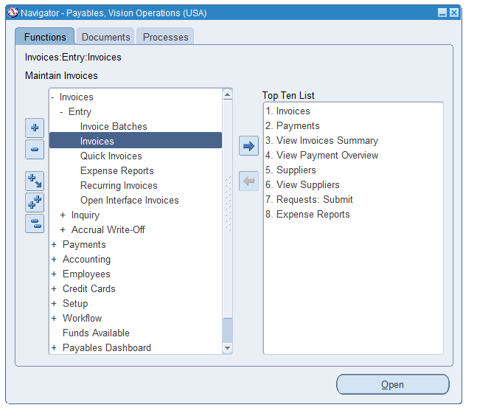

**#2 : From here i first queried my previous standard report by doing FN + F11**

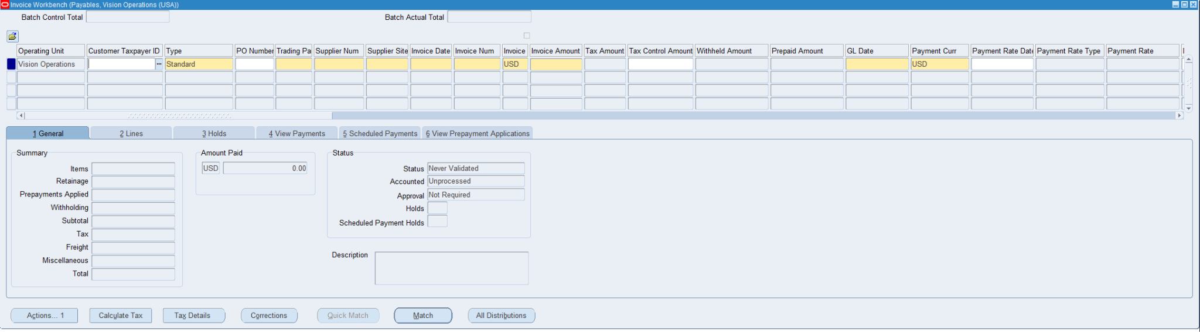

**#3: And got this screen which i typed in my naming convention which is CHAD%**

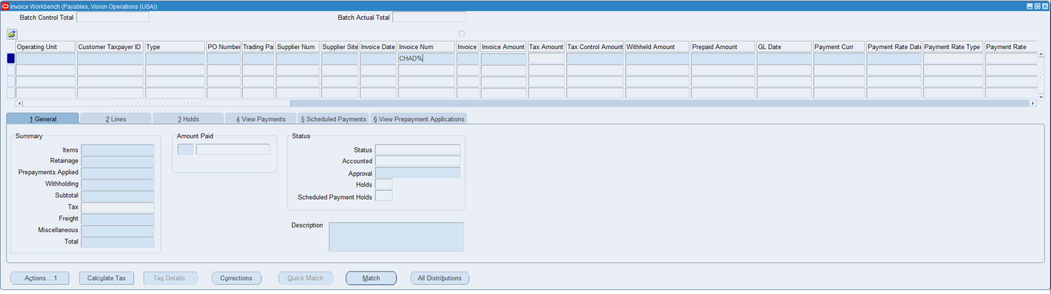

**#4:Once i typed in my naming convention i got my queries where i made a day prior**

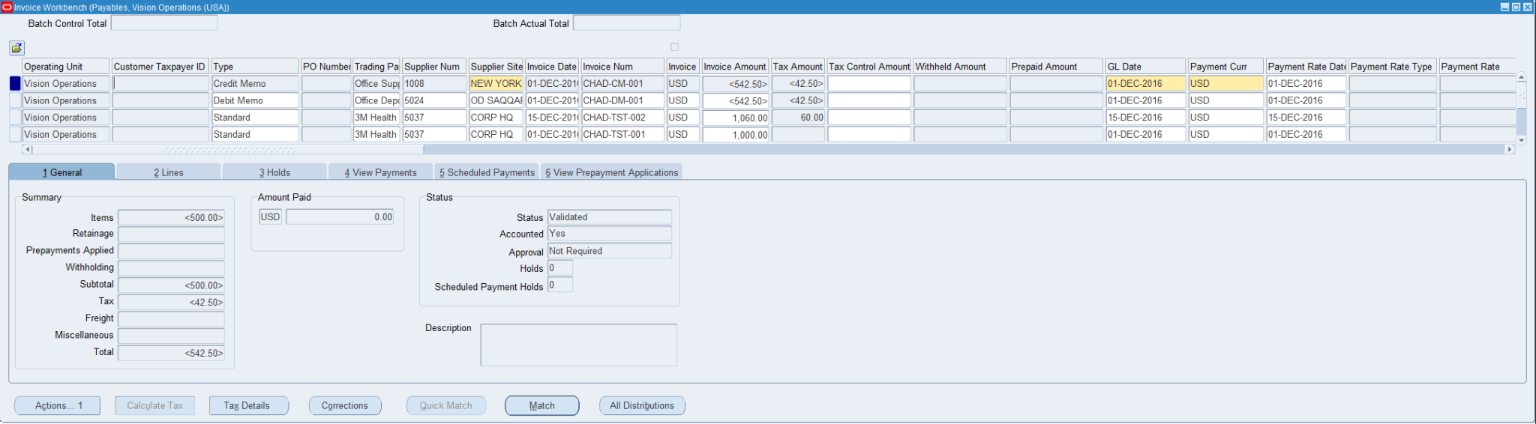

**#5: Once here i created a new standard report because my previous one was already completed because of the demonstration that was taught to me by Avic**

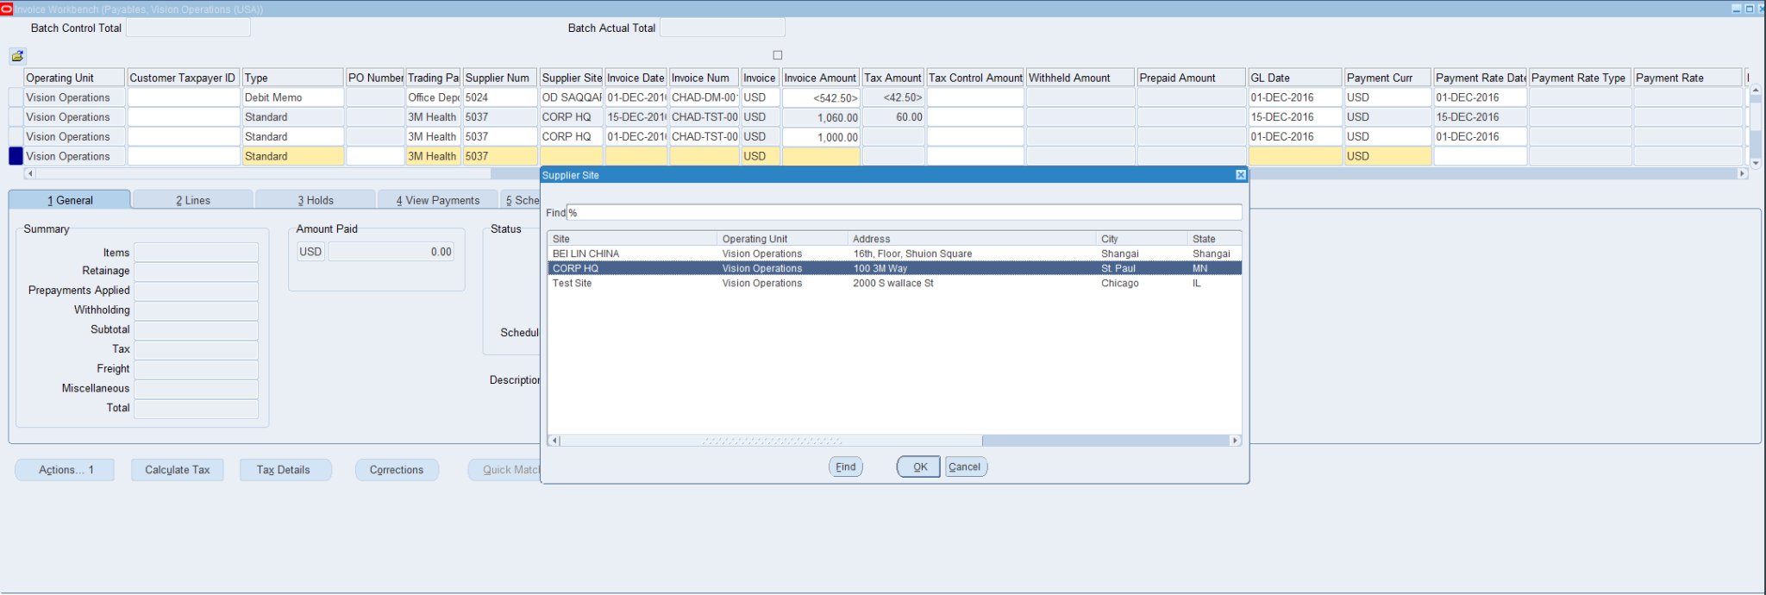

**#6: I filled in the necessary requirements for the new standard report which were Trading Partner,Supplier Number,Invoice Date, Invoice number, The invoice Amount**

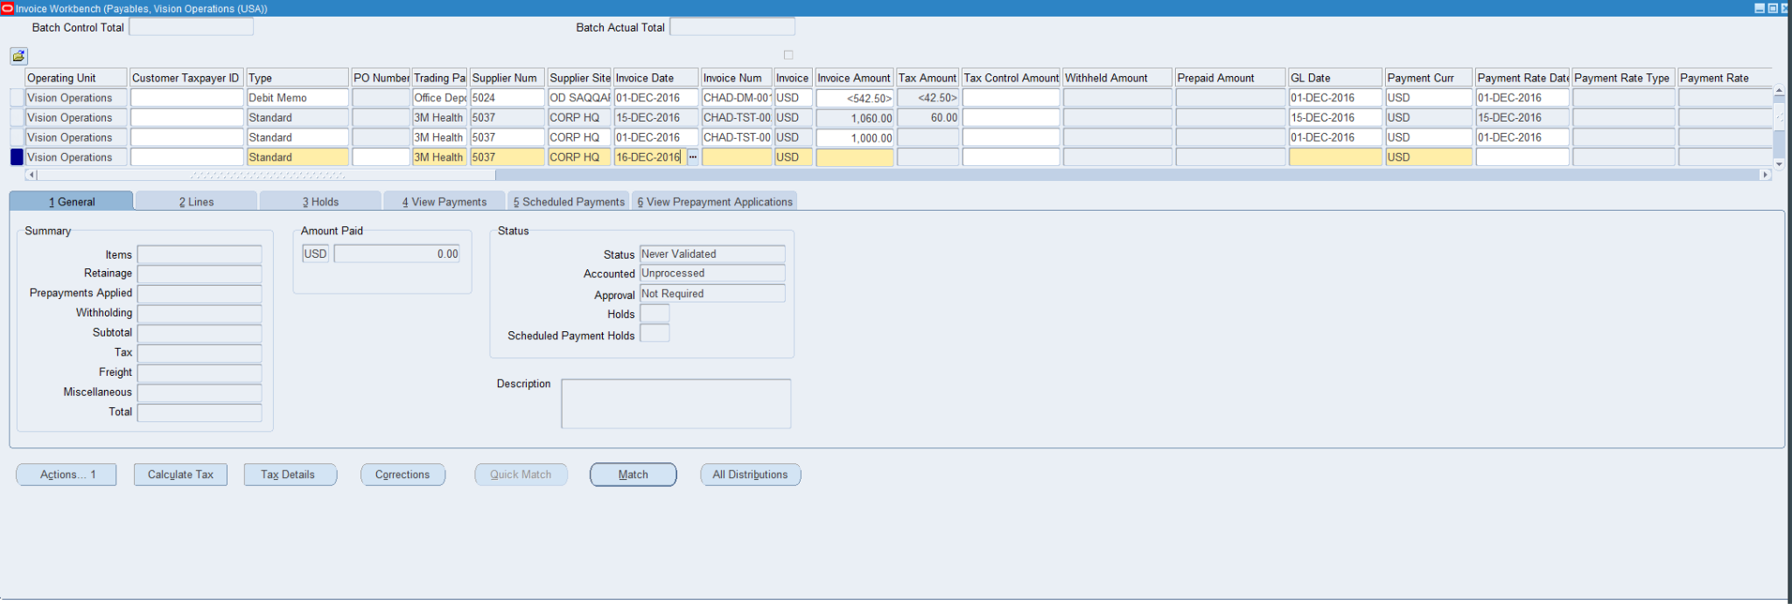

**Question #2**

**Create an Invoice Standard: [Payment team: Immediate].**

**#7:From here I created the standard report then I validated the amounts and the spending to get ready for the payment to get processed.**

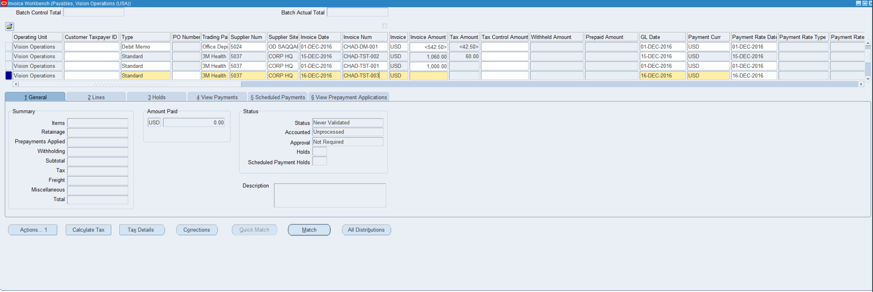

**#8:From here this is the process i took to create the report PART 1: Invoice Num: CHAD-TST-003**

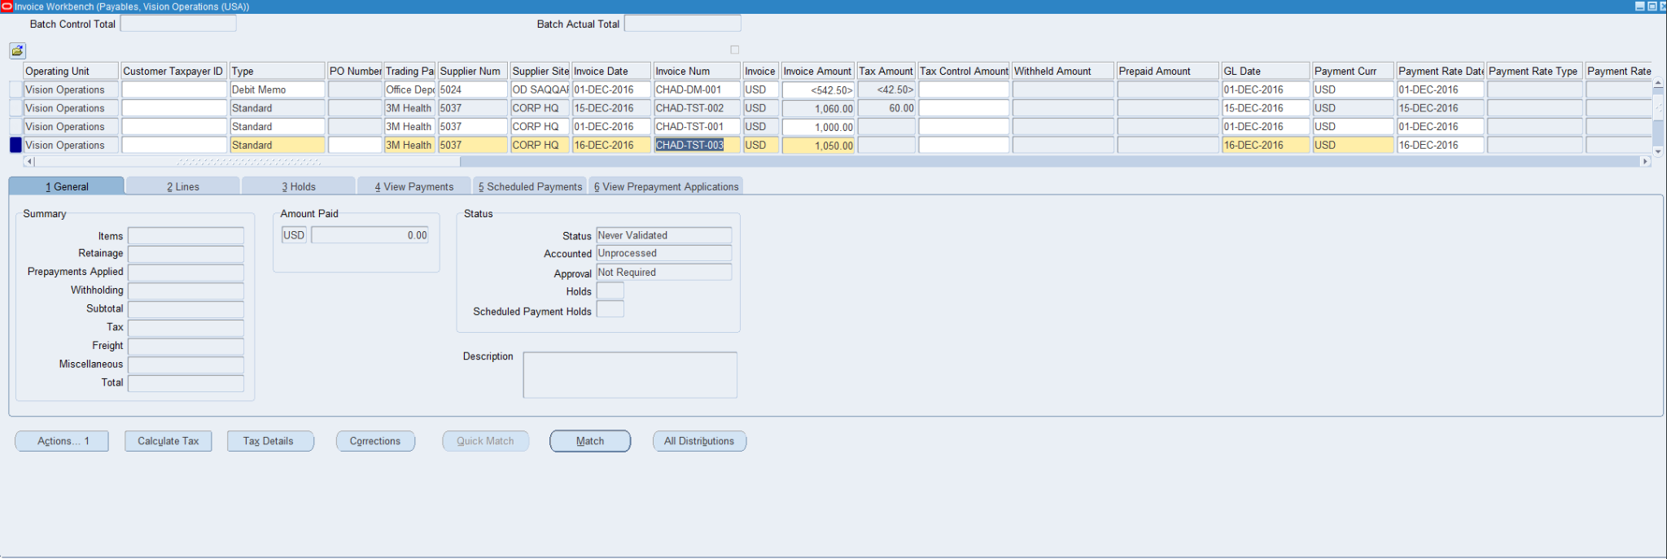

**#9: from here i am validating the Standard Report to get ready for Invoice payment: INVOICE PAYMENT: 1,050.00** 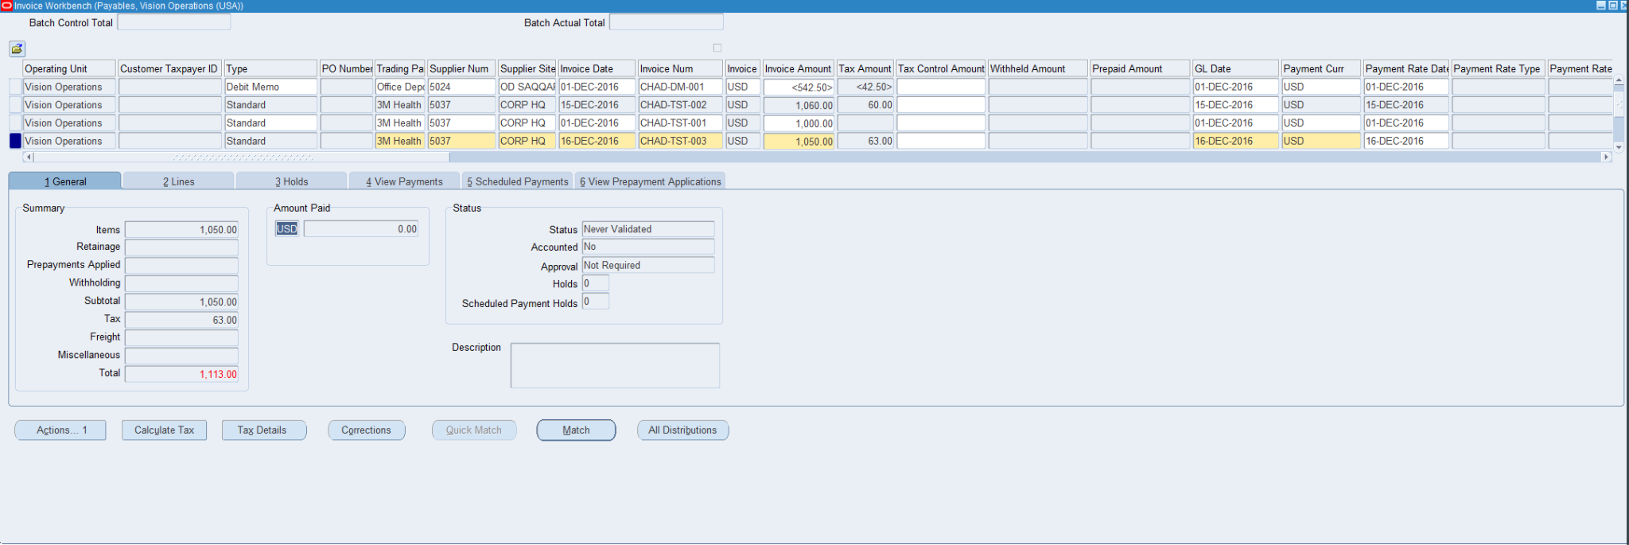

**#10: This is me calculating the tax for the order which makes the new invoice payment 1,113.00 because of the tax added on the order.**

**#11:This is me updating the invoice amount and revalidating the standard report to get it ready for the invoice payment section**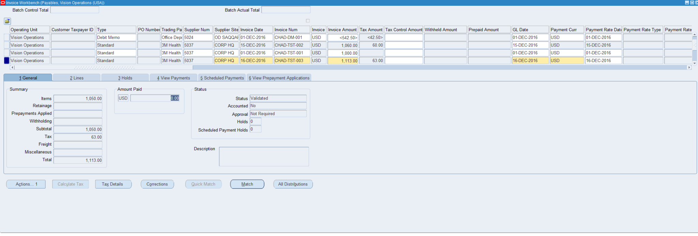

**#12:This is the last step I take to get the standard report ready for the invoice payment, which is using the final post to create the report in the system so I can start the invoice payment part.**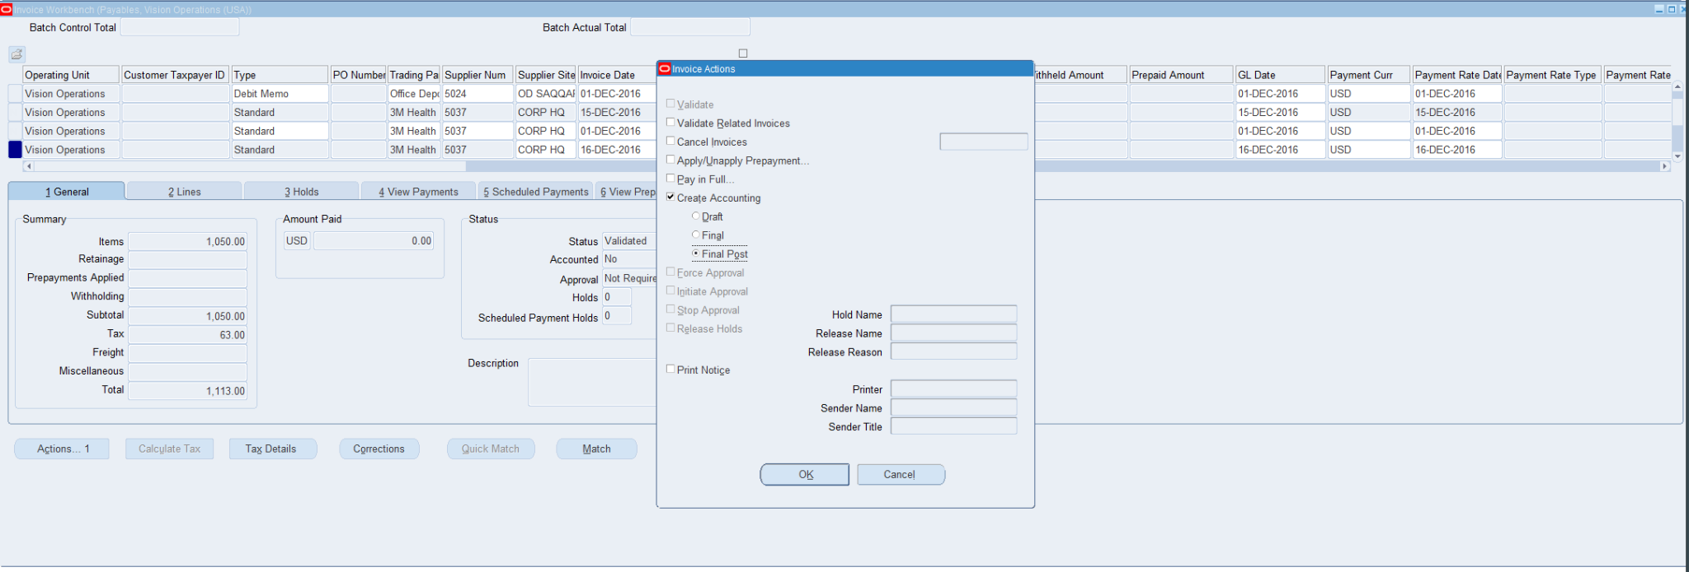

**Question #3**

**Do Create Accounting & Transfer to General Ledger:**

**#13: This is the confirmation of the creation of the accounting report of the transaction.**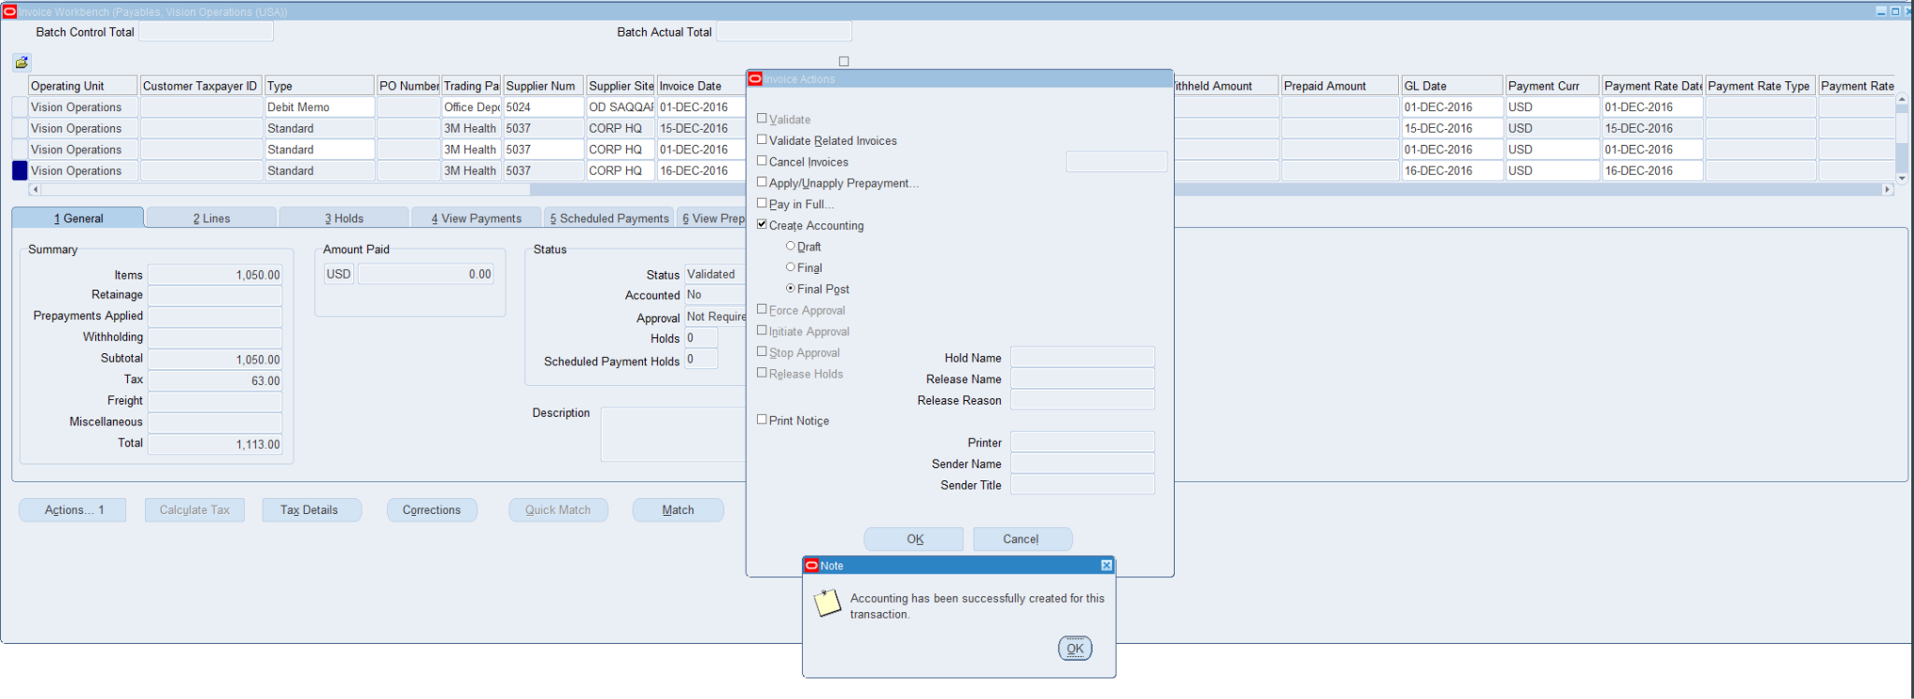

**Question #4**

**Create A debit Memo: (Validate & Create accounting)**

**#1: I followed this path to get to Invoices so i could start with making a the debit memo**

**Payables > Invoices > Entry > Invoices**

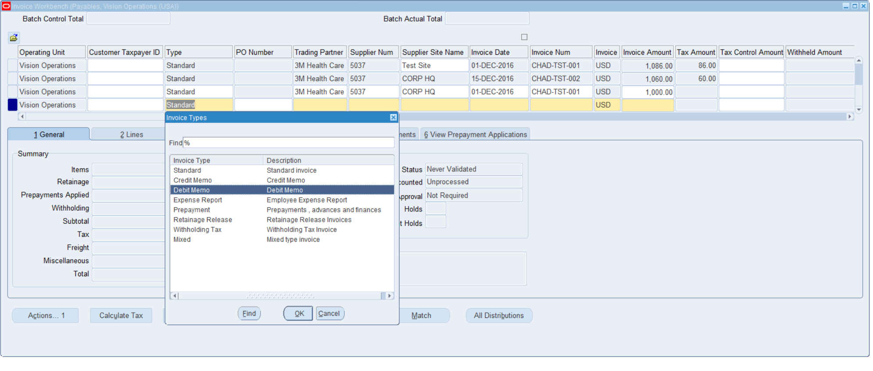

**From here i added the related fields to create the debit memo, Trading partner, invoice date,invoice data, and the invoice amount**

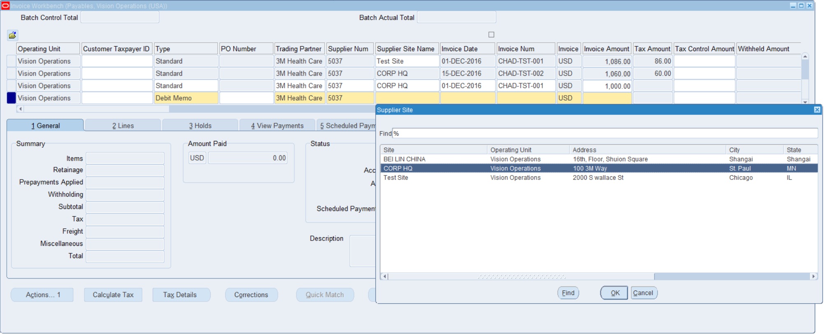

**I added the date of 12/02/16**

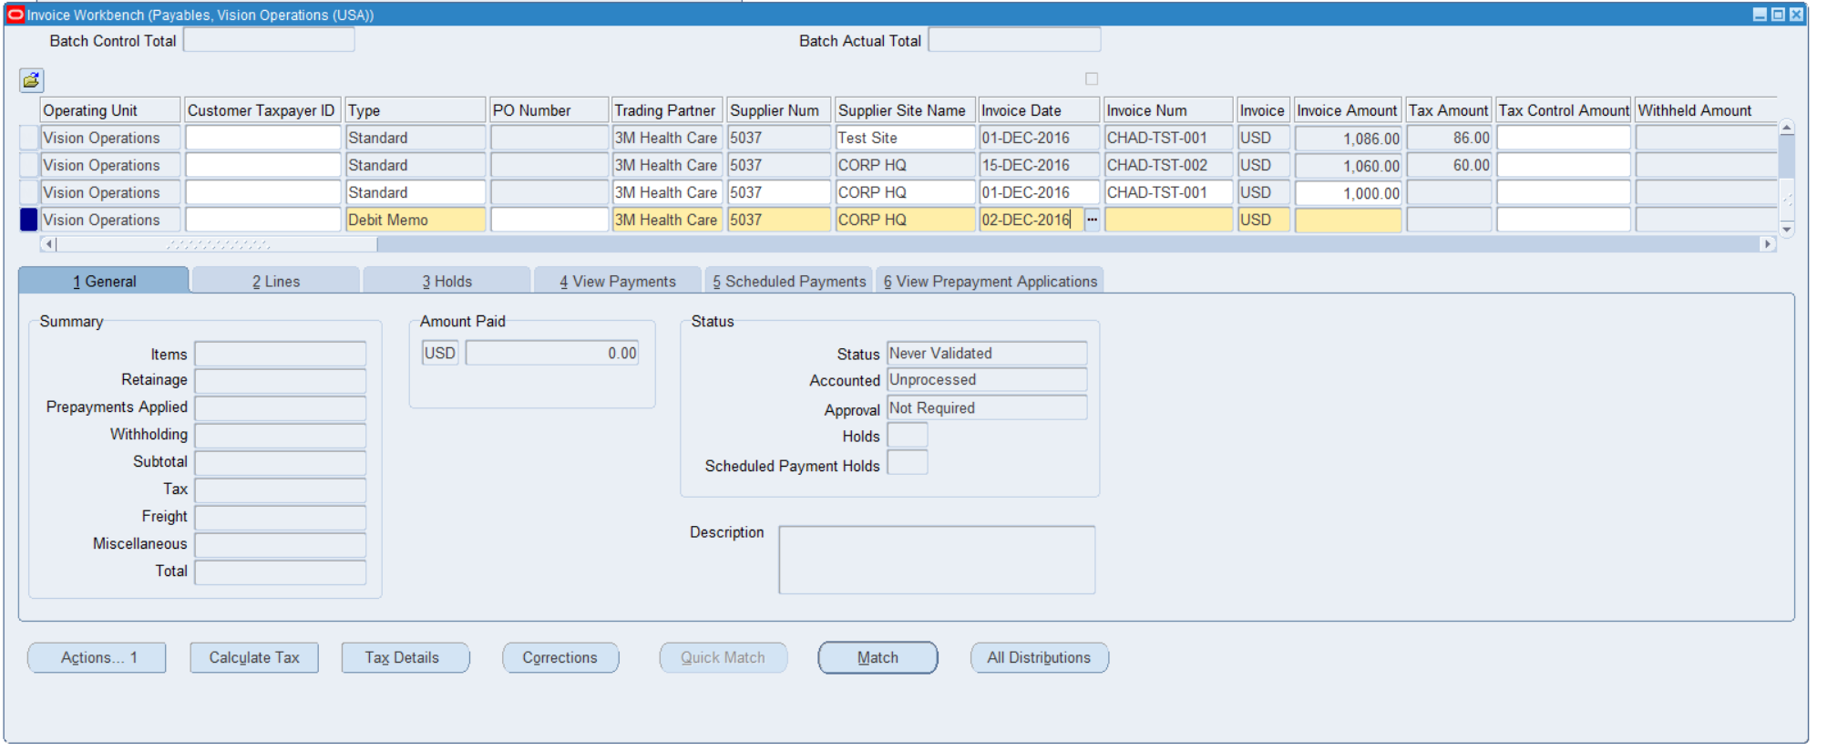

**I added the invoice number**

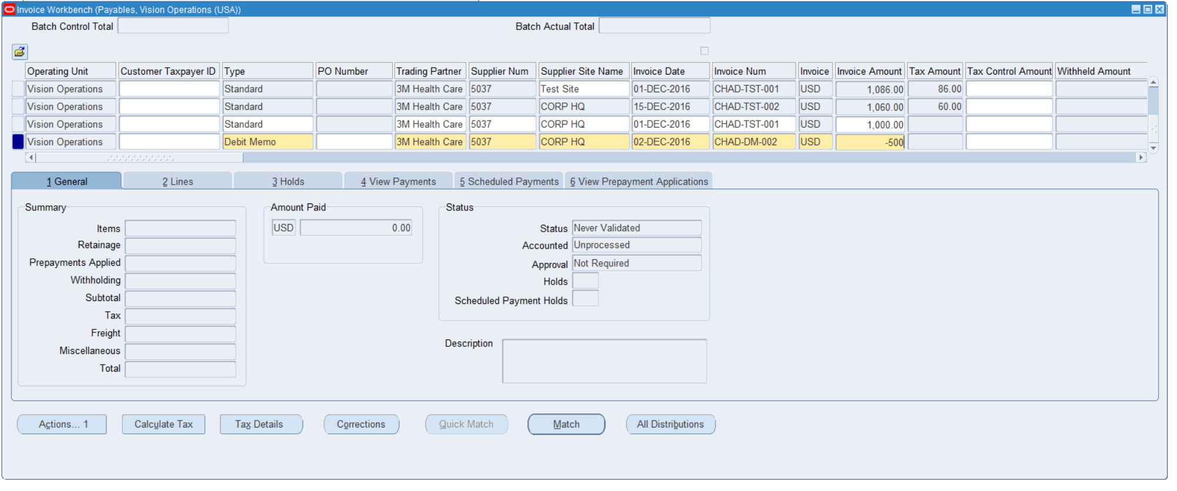

**I added the invoice amount**



**I then validated the amount of the debit memo**

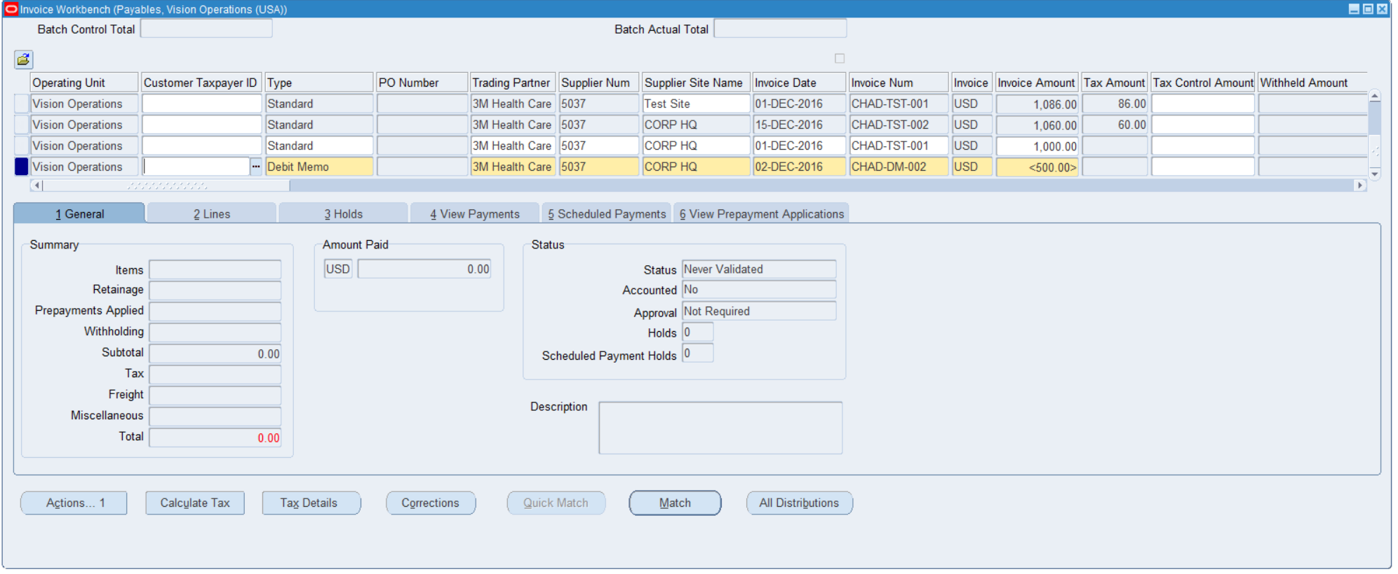

**I then calculated the tax and went from there to validate the debit memo.**

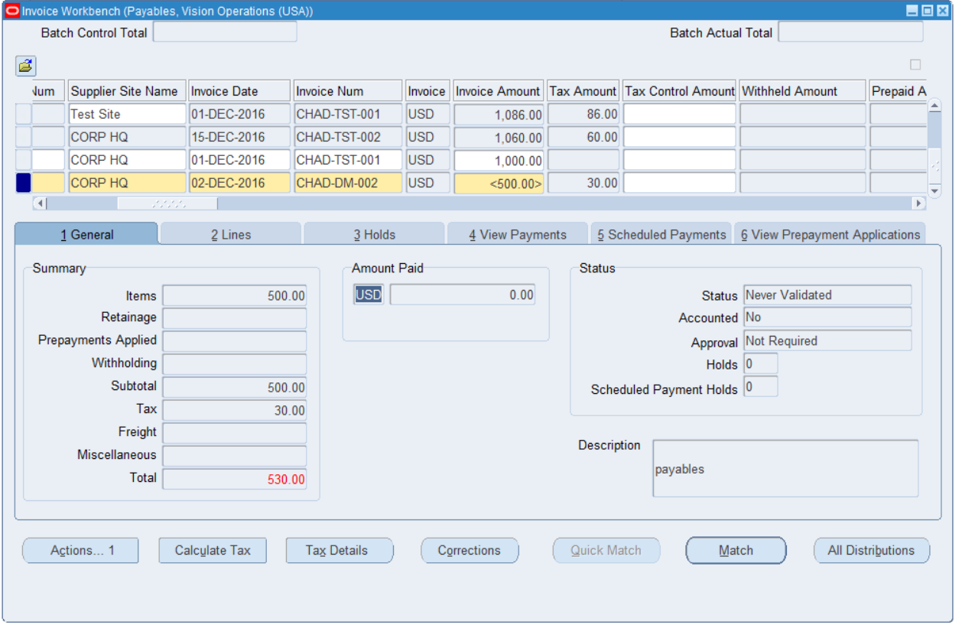

**The tax equaled to $30 so it added for the total which makes the final total is $530**

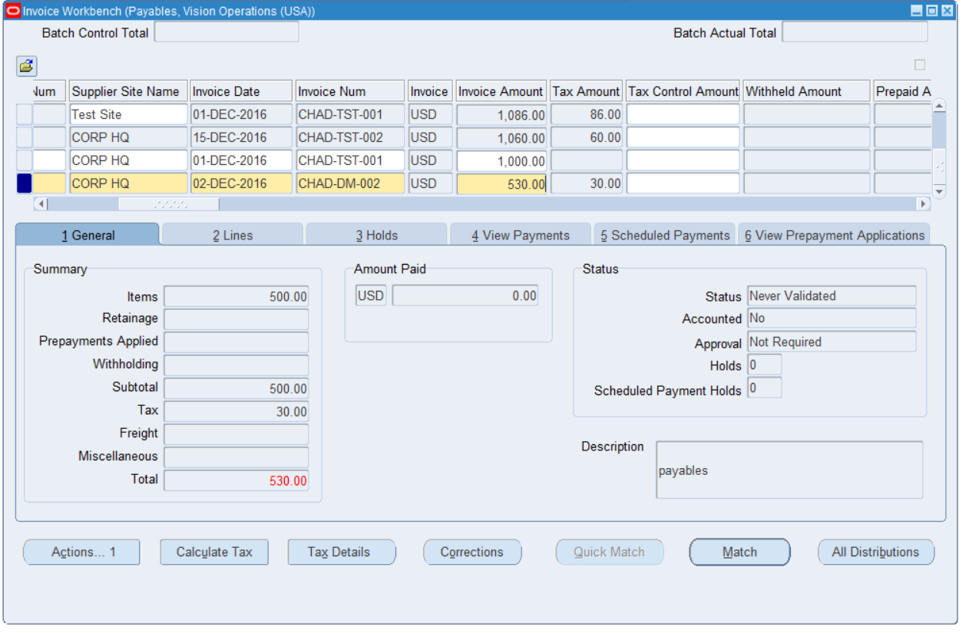

**I added $-530.00 to validate and update the final amount for the validation.**

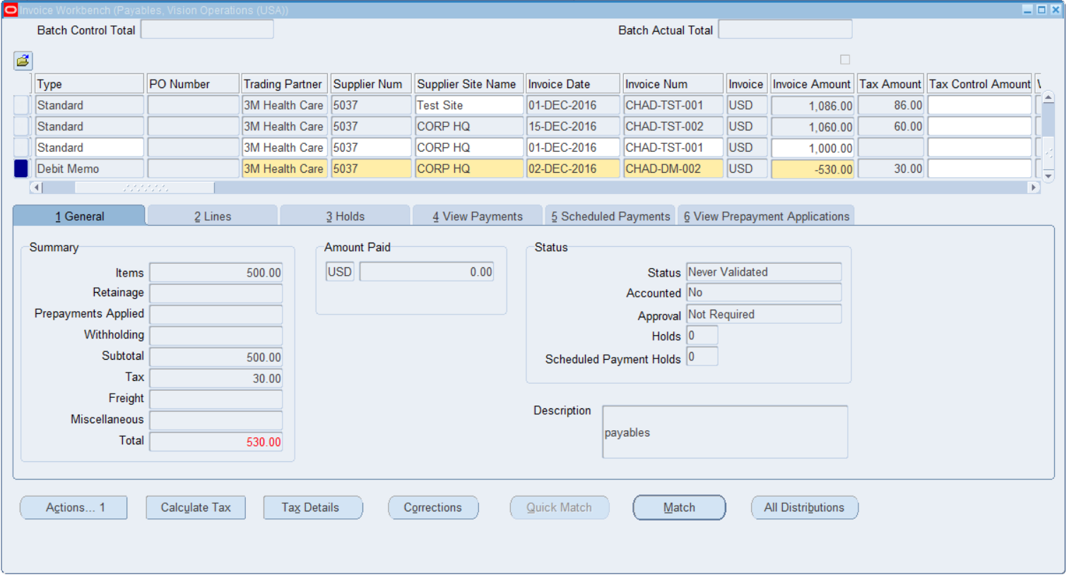

**I got this message because it was similar to my other memos**

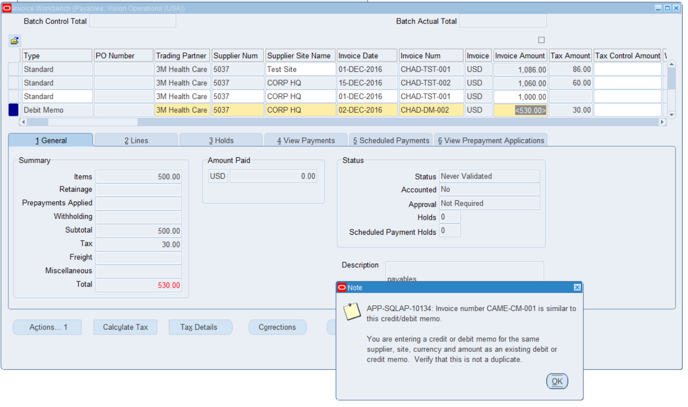

**I then validated the amount of the debit memo.**

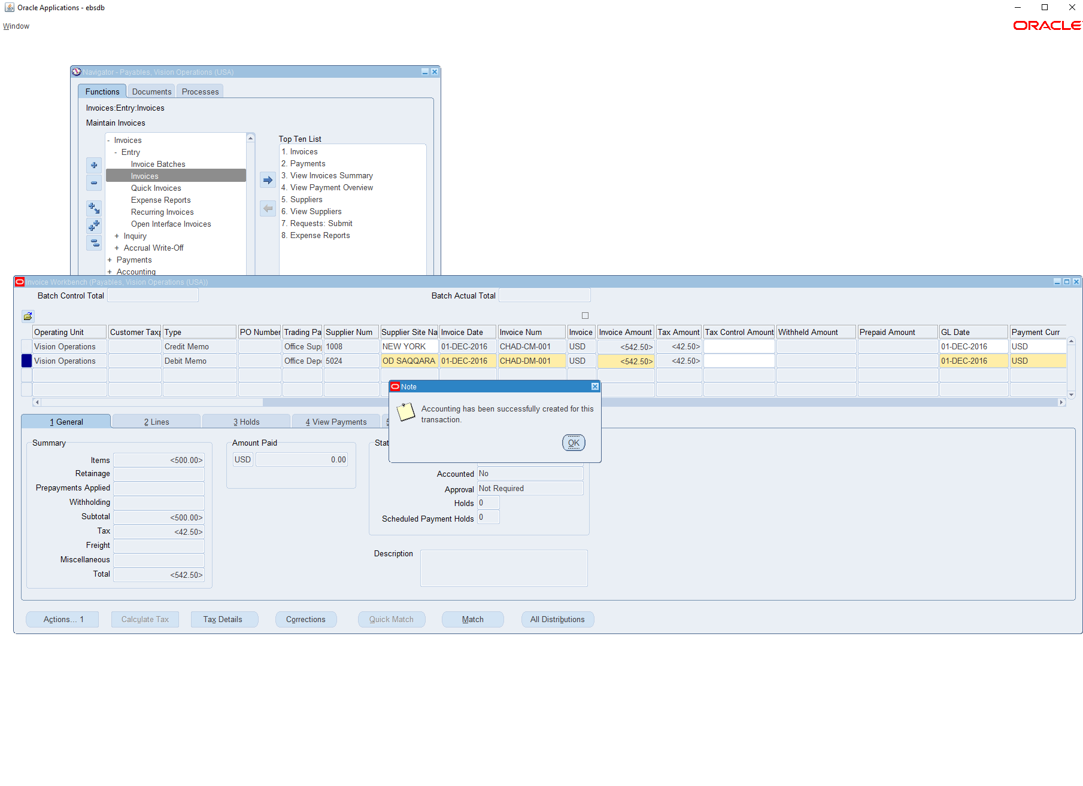

**i**

**Question #5**

**Create a Credit Memo (Validate & Create accounting)**

**#1: I followed this path to get to Invoices so i could start with making a the credit memo**

**Payables > Invoices > Entry > Invoices**

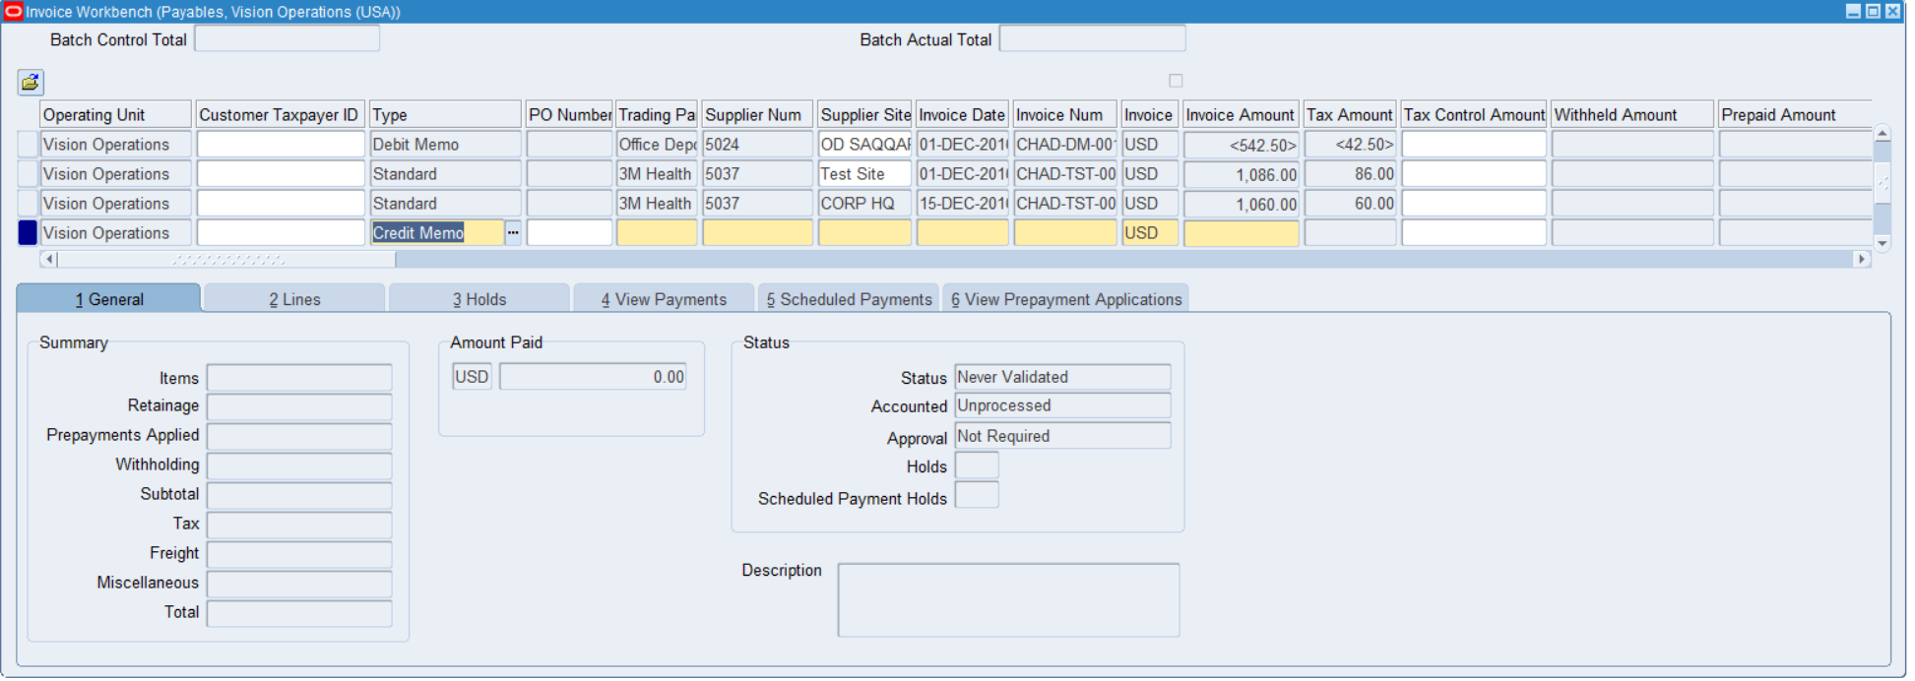

**I added the payment terms to immediate and the payment check**

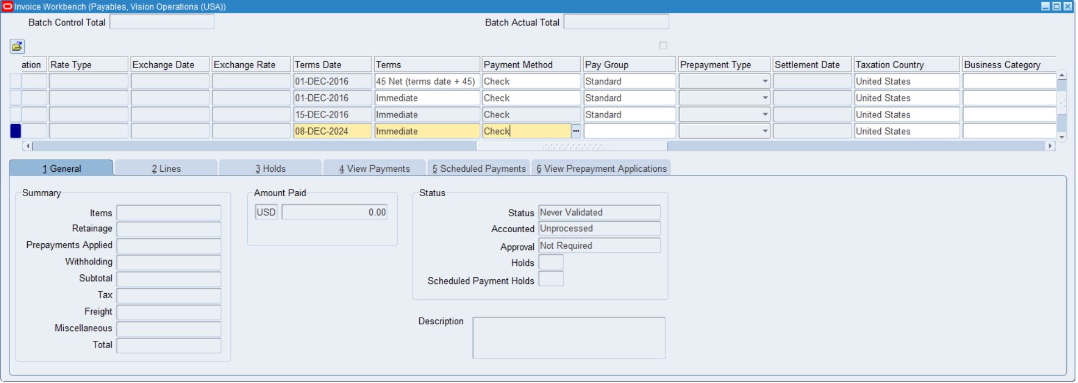

**I added the required files for the creation of the credit memo**

**Trading partner(Office Depot Inc.),Supplier NUM (5024),Supplier site Name(OD SAQQARA),Invoice Date(12/02/16),Invoice NUM(CHAD-CM-005),Invoice Amount(600).**

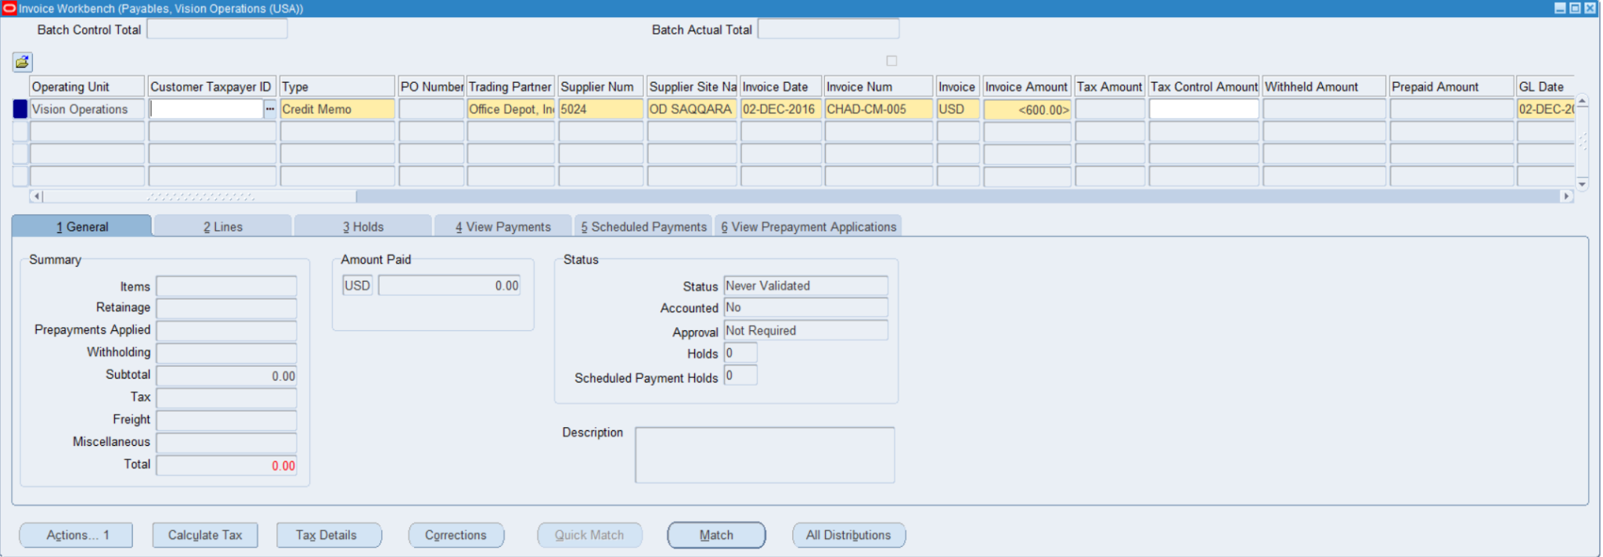

**I then went to lines to match the amount as the same as the invoice for validation purposes.**

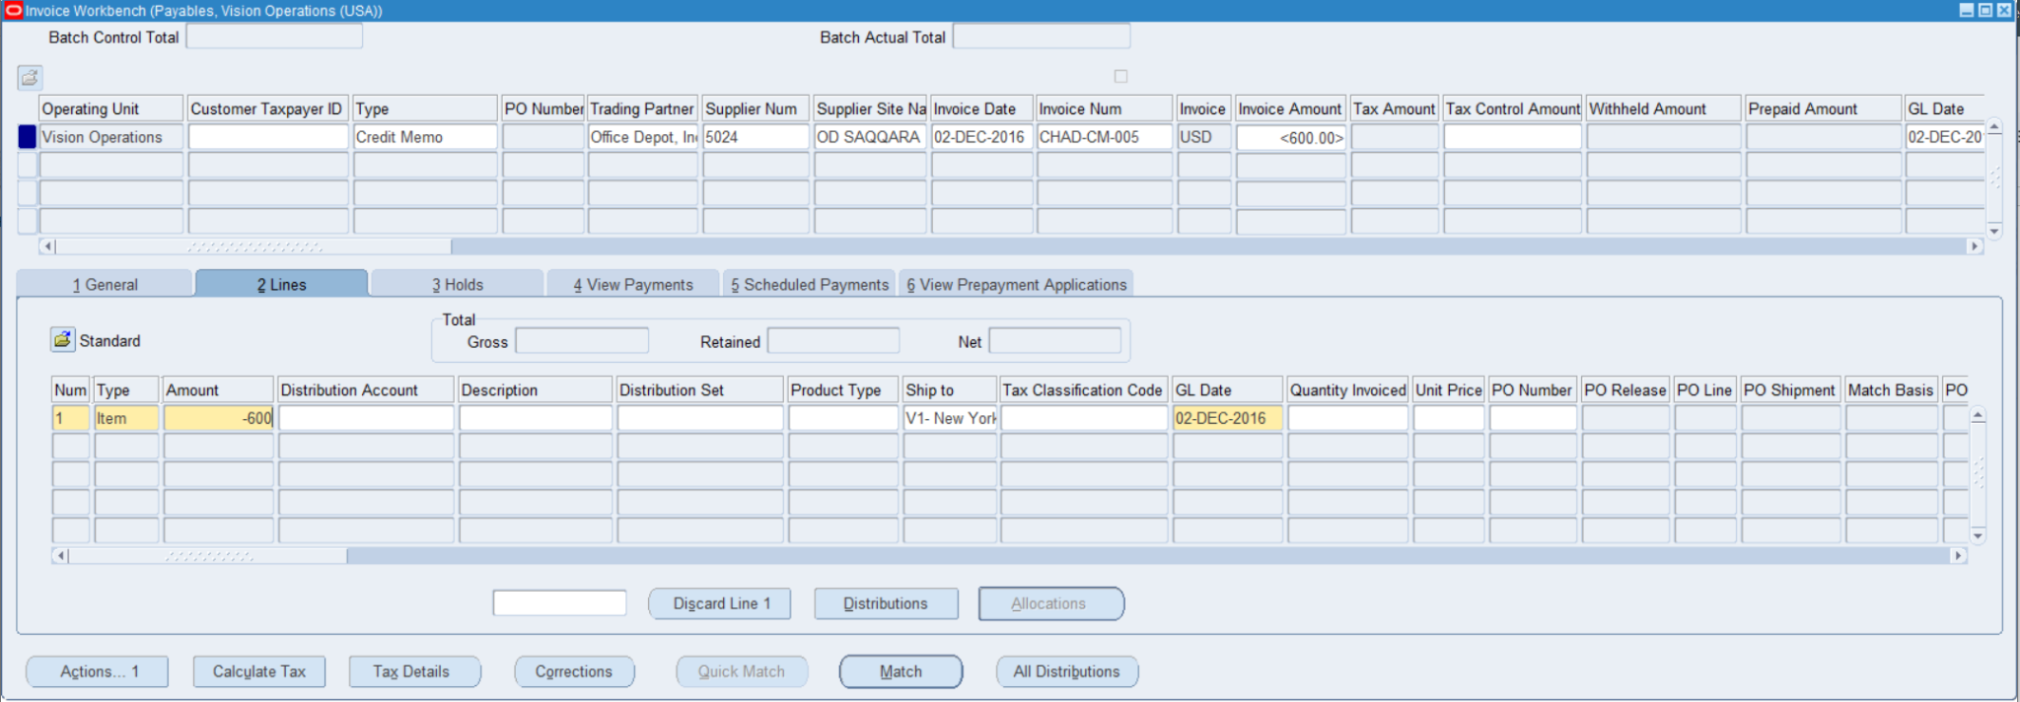

**I put $600 here amount $600, and the distribution account, the product type, GL Date (12/02/2016).**

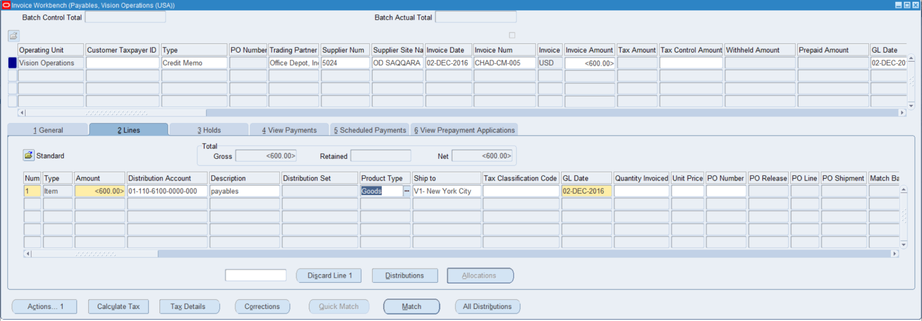

**From here I calculated tax which added $51.00 to the final total.**

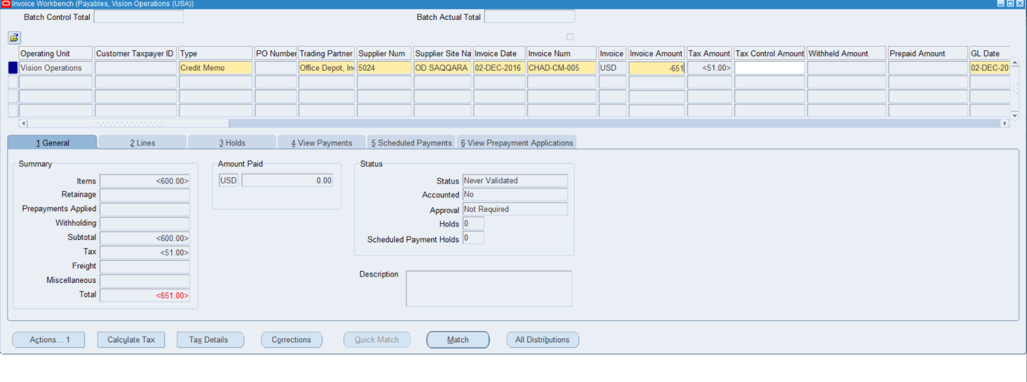

**I validated the credit memo by using actions the, the validate check mark**

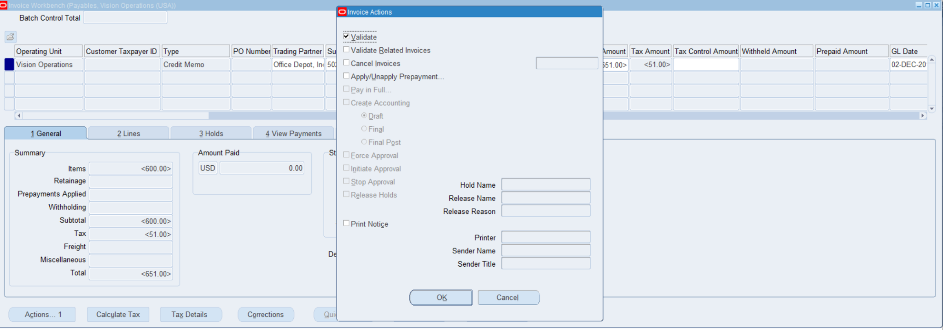

**I validated the credit memo and the amount to complete the validation process.**

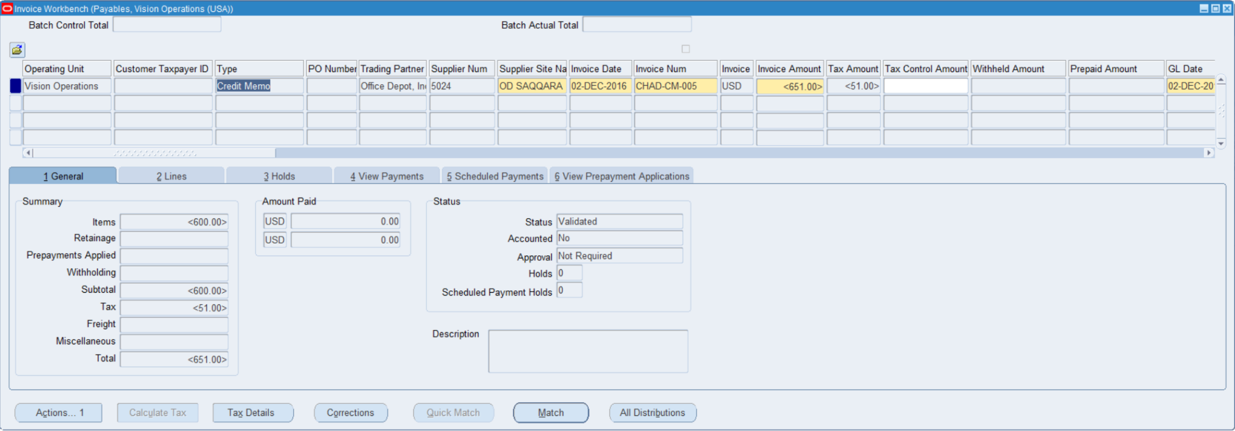

**I then created an accounting final post to create in GL.**

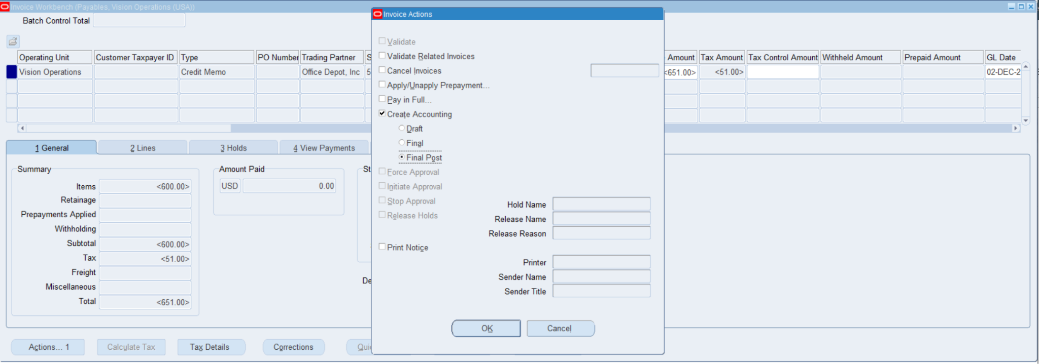

**Question #6**

**Query a PO based Invoice & check the Po match details.**

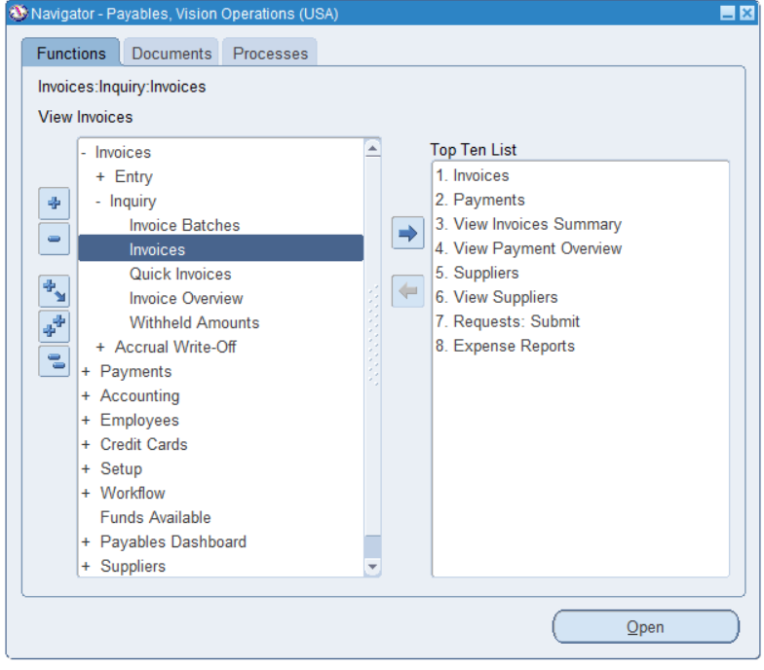

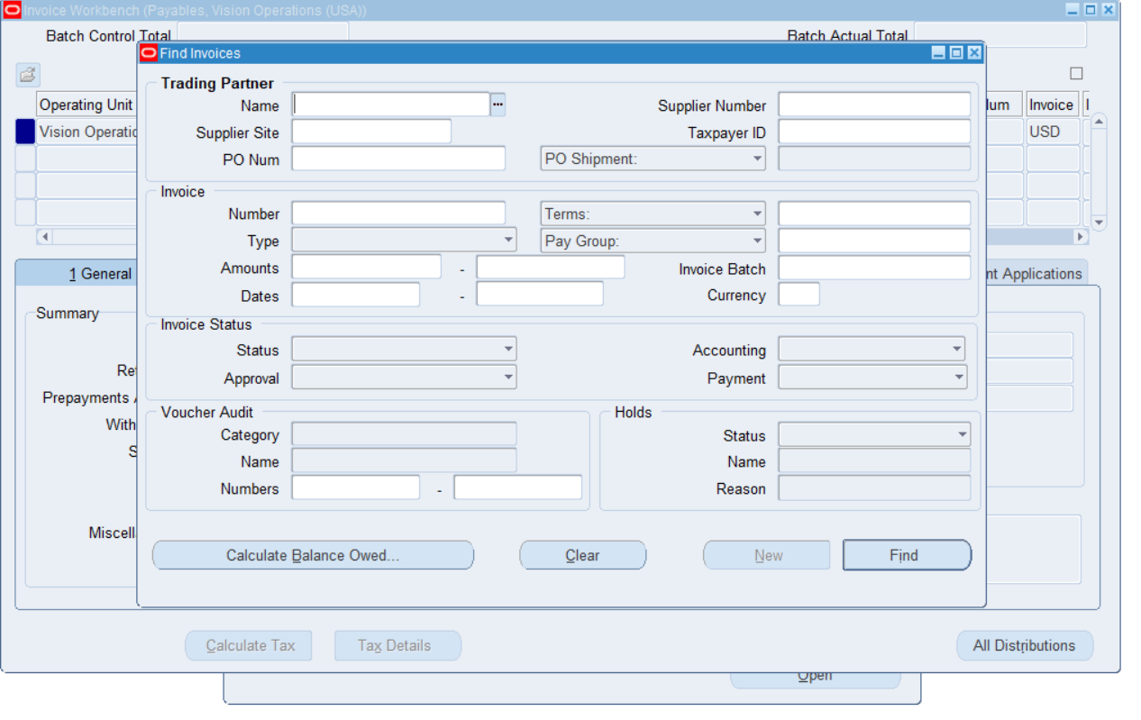

**Im matching PO Number 4806**

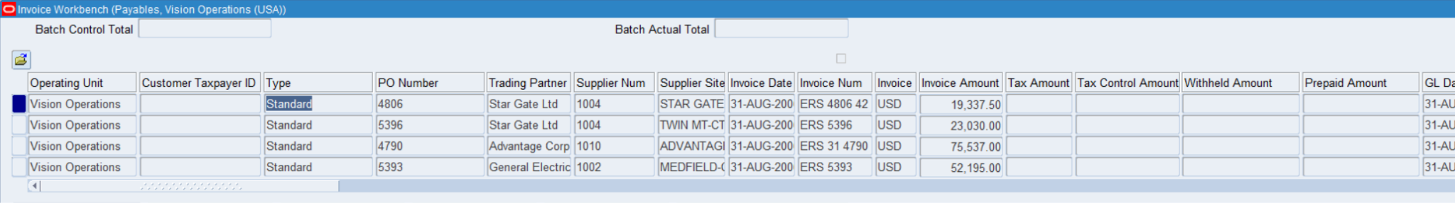

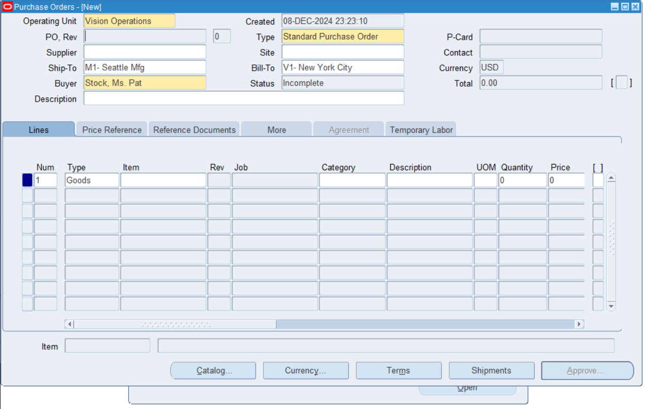

**I matched the PO with the invoice number to the PO query**

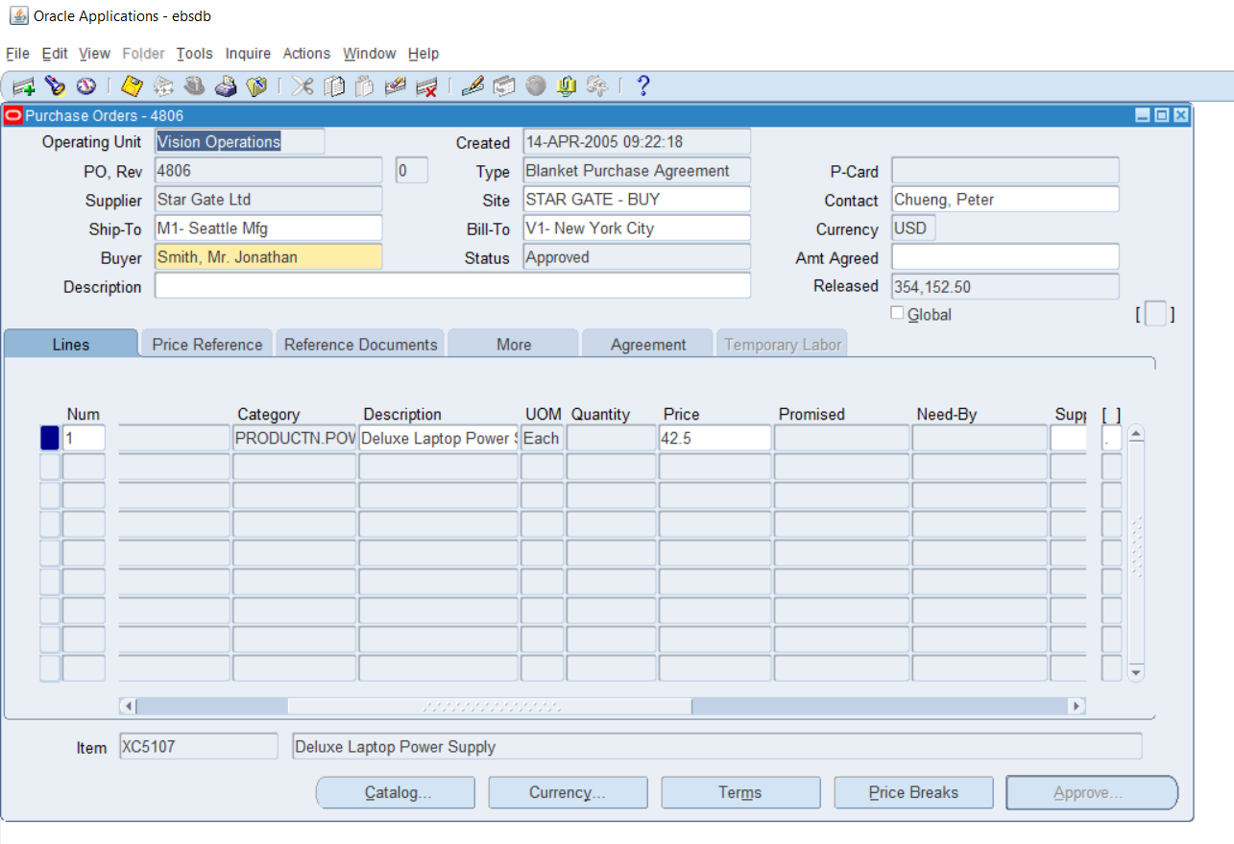

**Question #7**

**Create a PRE-Payment Invoice [Temporary].**

**#1: I followed this path to get to Invoices so i could start with making a the prepayment memo**

**Payables > Invoices > Entry > Invoices**

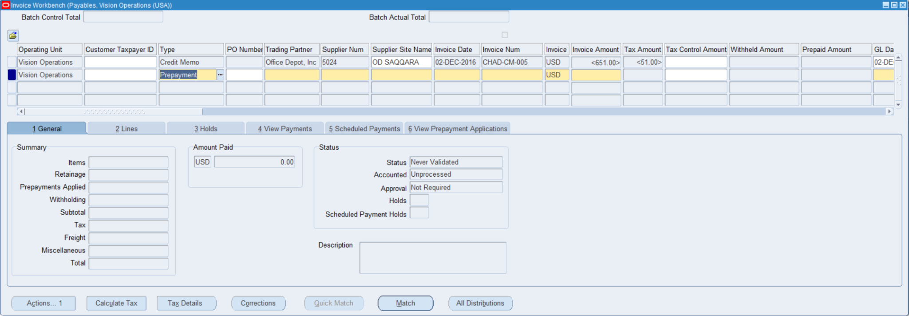

**I added the trading partner and supplier site, which adds the address, city, and state to the invoice.**

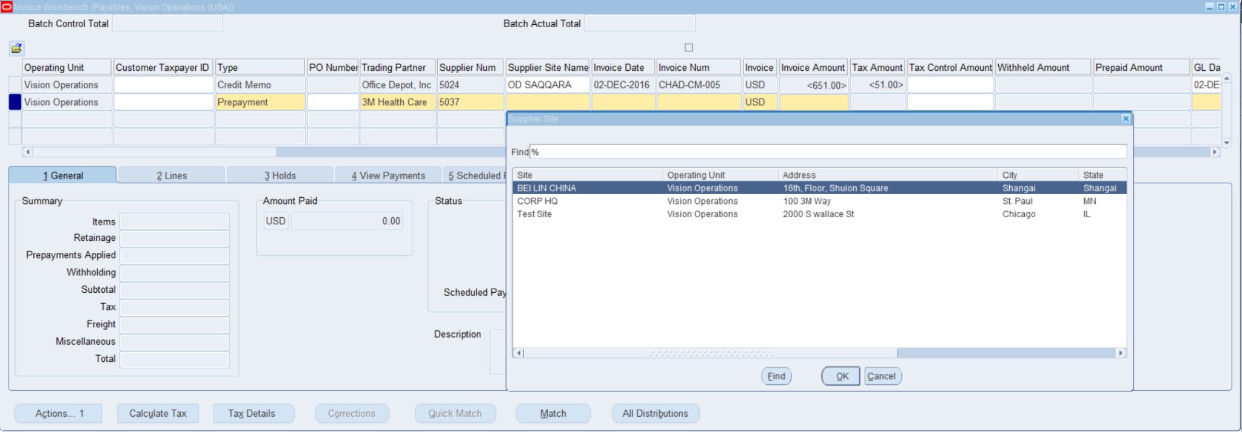

**I added the invoice date(12/03/2016),the invoice num(CHAD-PRE-002), and the invoice amount(1,600.00)**

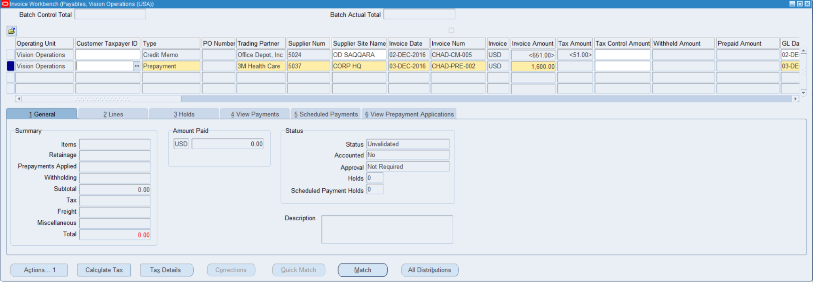

**I then went to lines to add the amount and the date of the GL which sends the entry to the journal.**

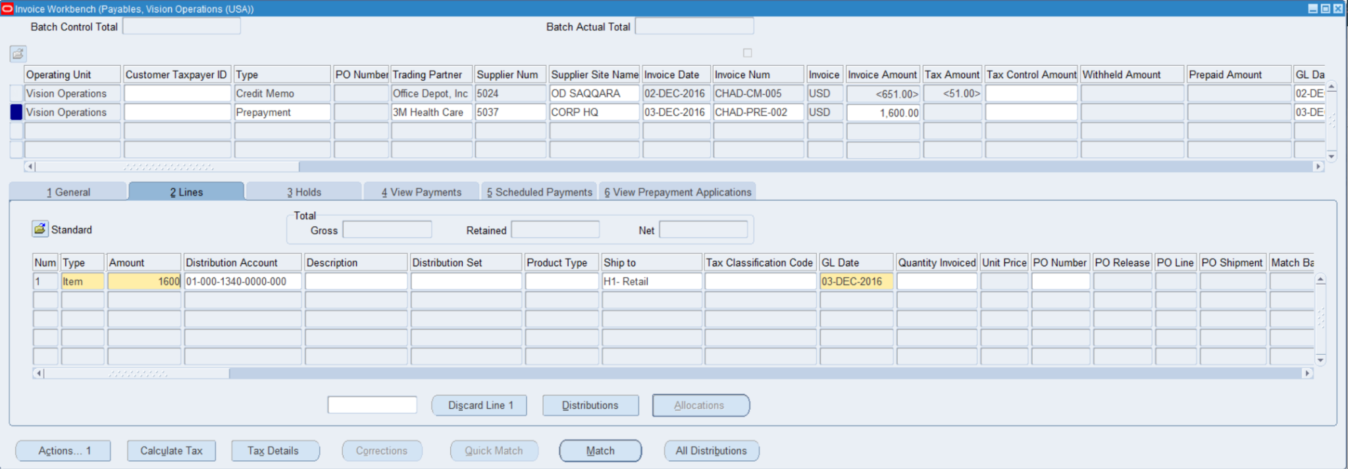

**From here I calculated the tax to figure out the full amount to process with the full prepayment.**

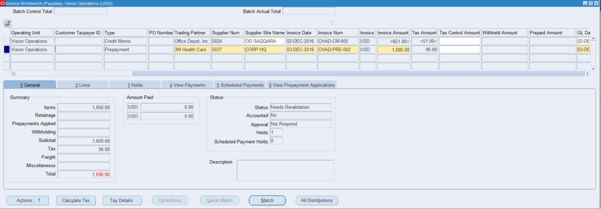

**I do 2 things here 1st i update the invoice amount to match the total with tax including which totals out to $1,696.00 so the tax is $96 the second thing i do is validate the prepayment to get ready for the payment.**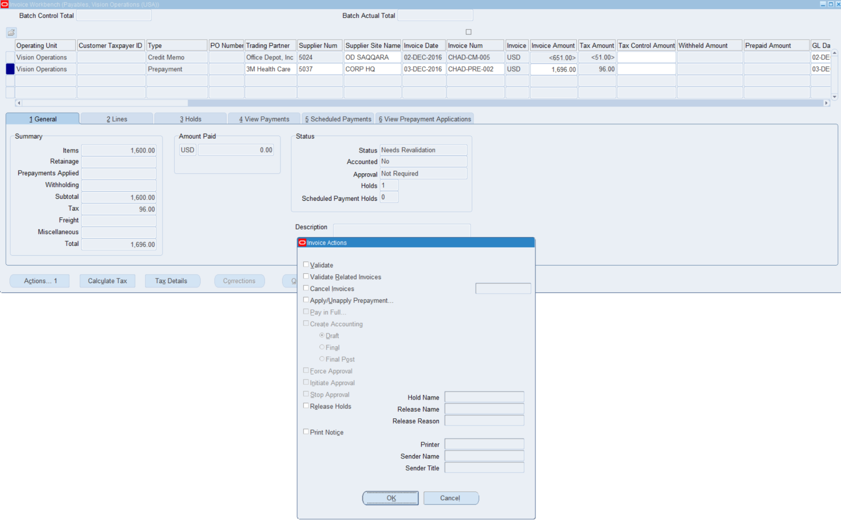

**From here i clicked on pay in Full to start the process of paying the prepayment.**

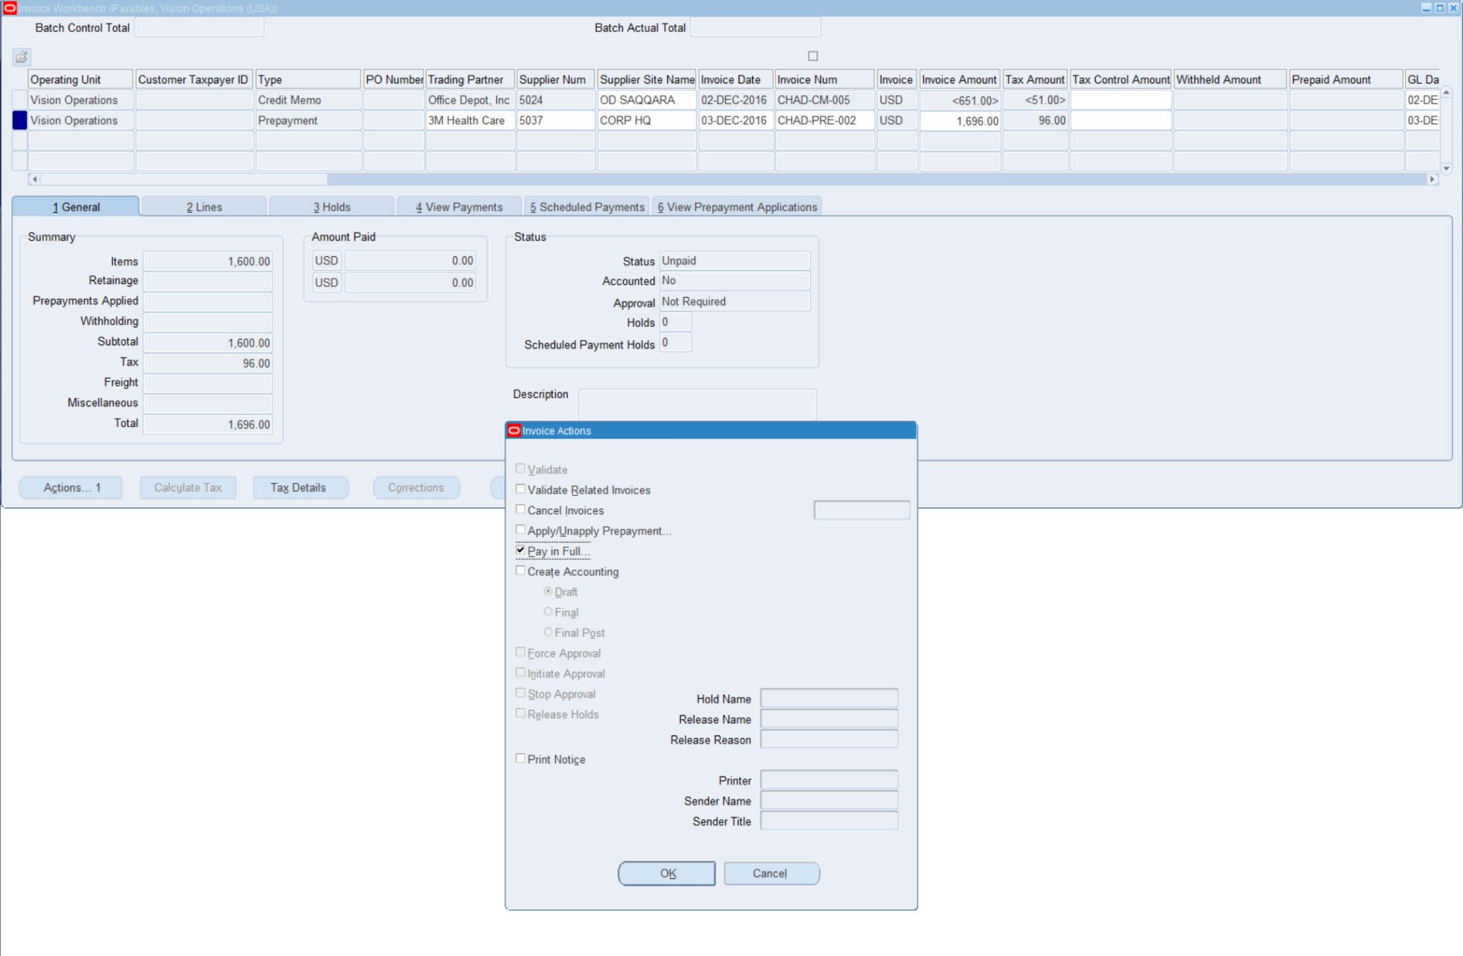

**From here i added the required fields which is the trading Partner(3M Health Care), the Payment date**

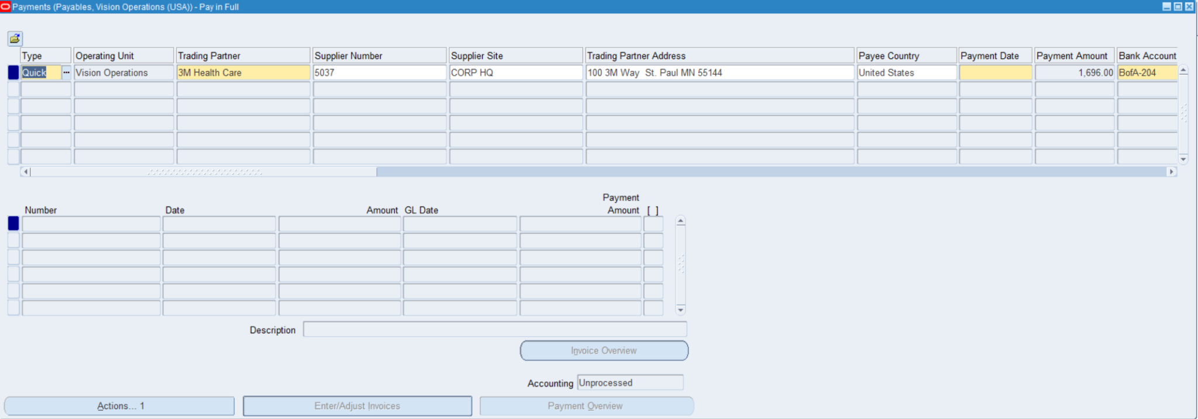

**I also added the Payment method and the payment Process Profile(Check-USD)**

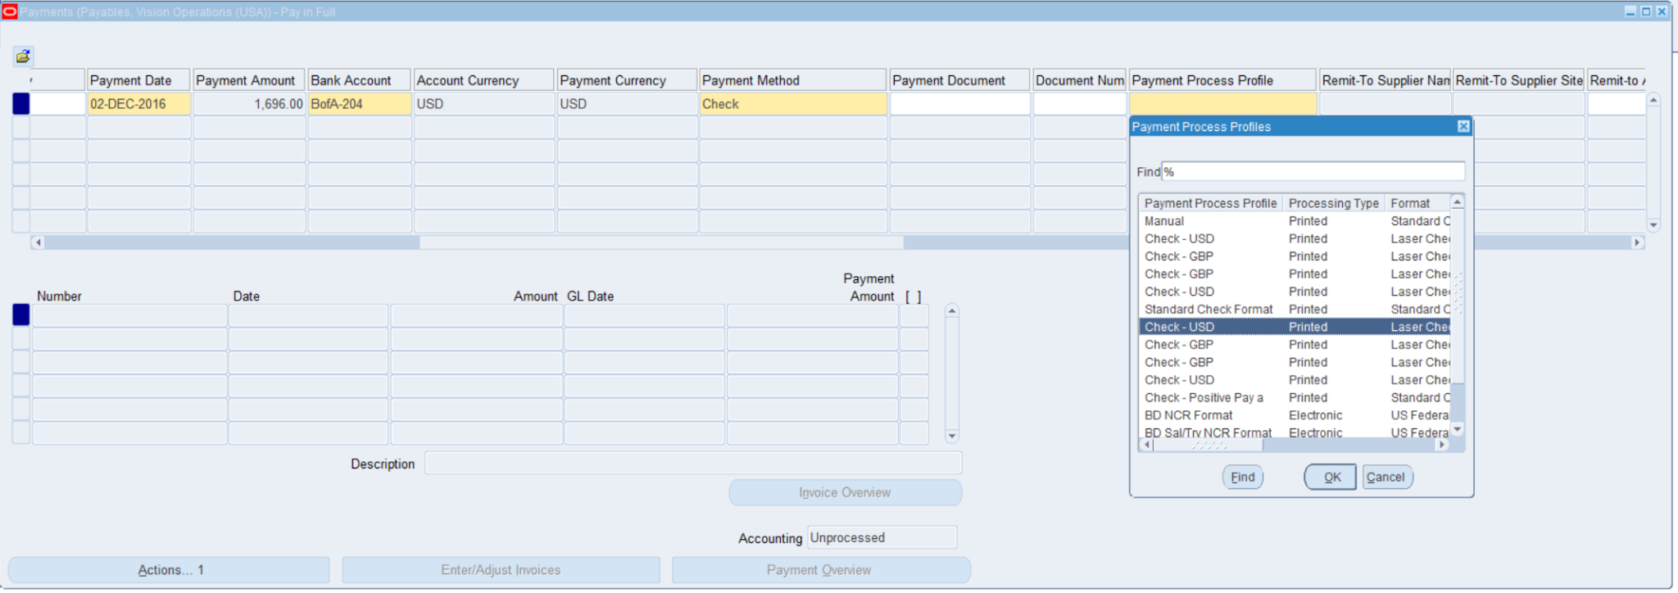

**I then went to actions then created the accounting to complete the payment.**

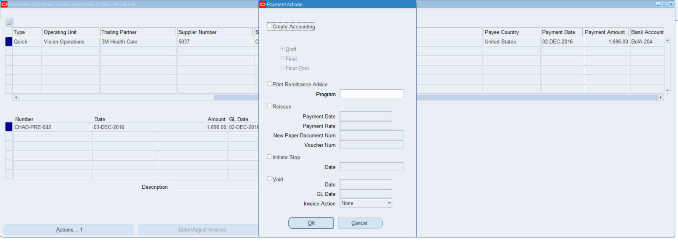

**I completed the payment by clicking final post.**

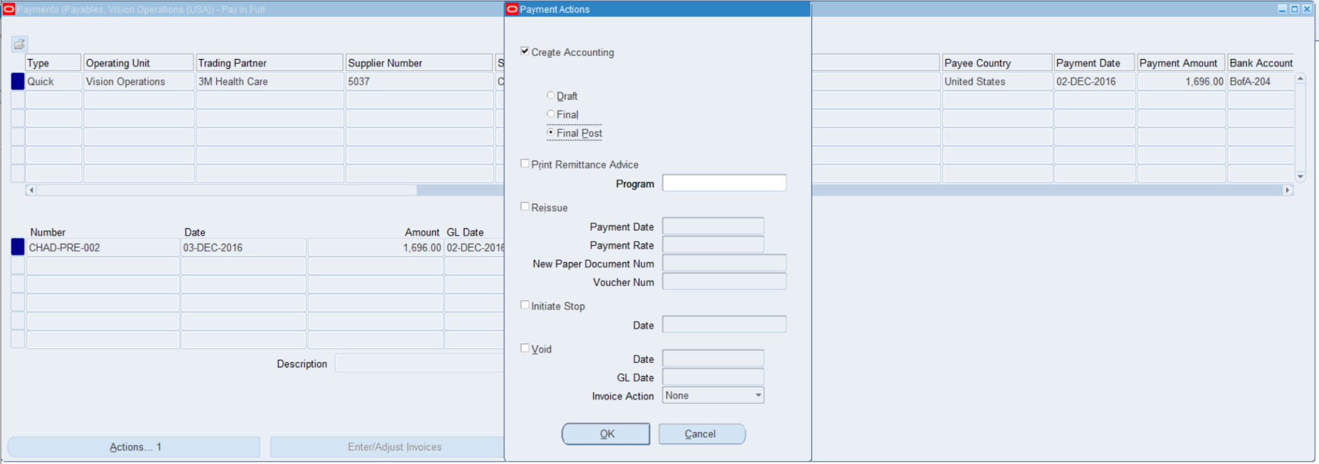

**From here the p[ayament was fully paid but i still needed to process the accounting to send to GL**

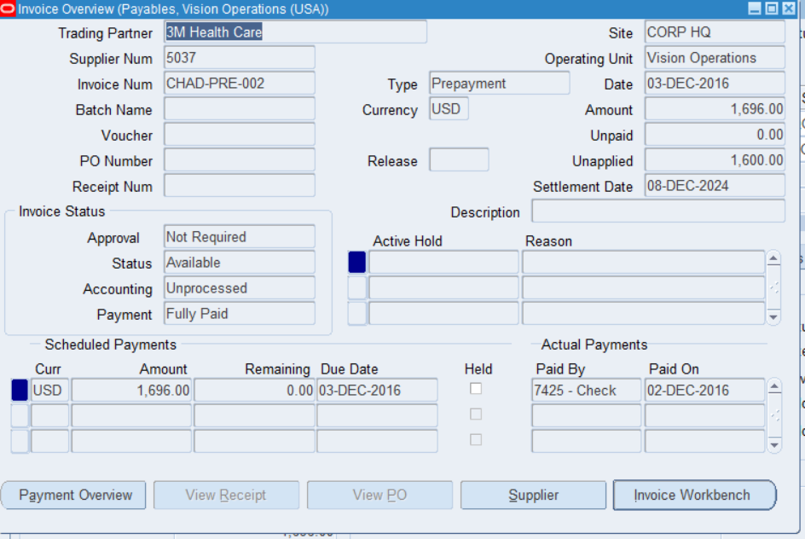

**I started this process by going to back to the invoice workbench and validating the record for the payment vaildating**

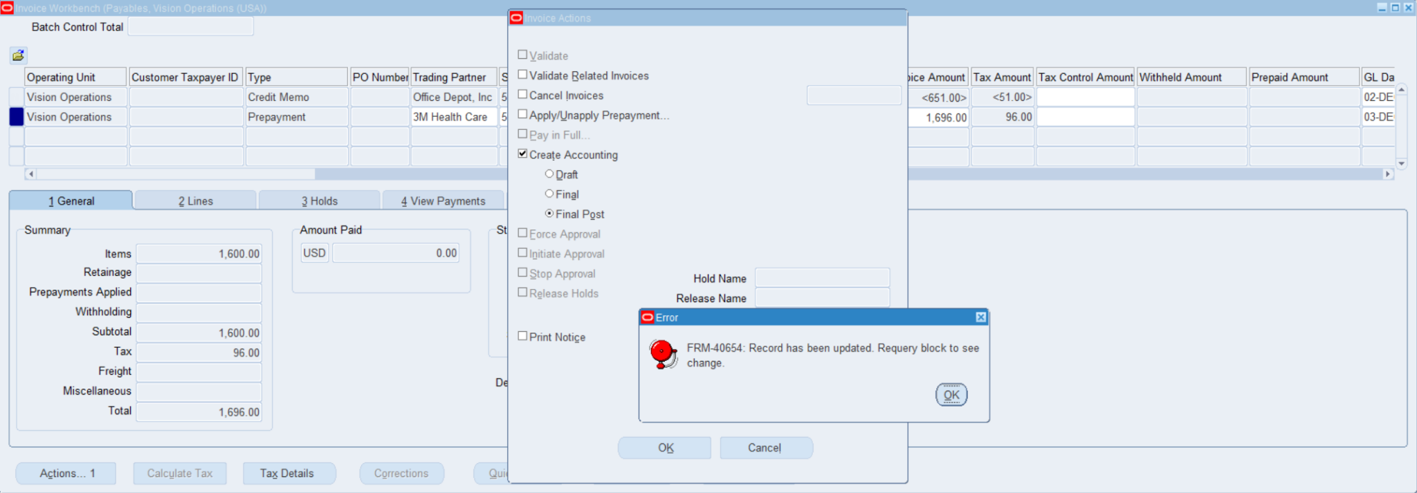

**I then go back to the payments and do the accounting report to send the record to GL for the journal Entry**

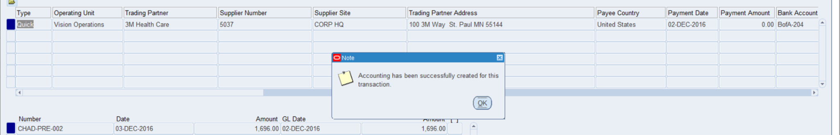

**this completed the prepayment for the invoice**

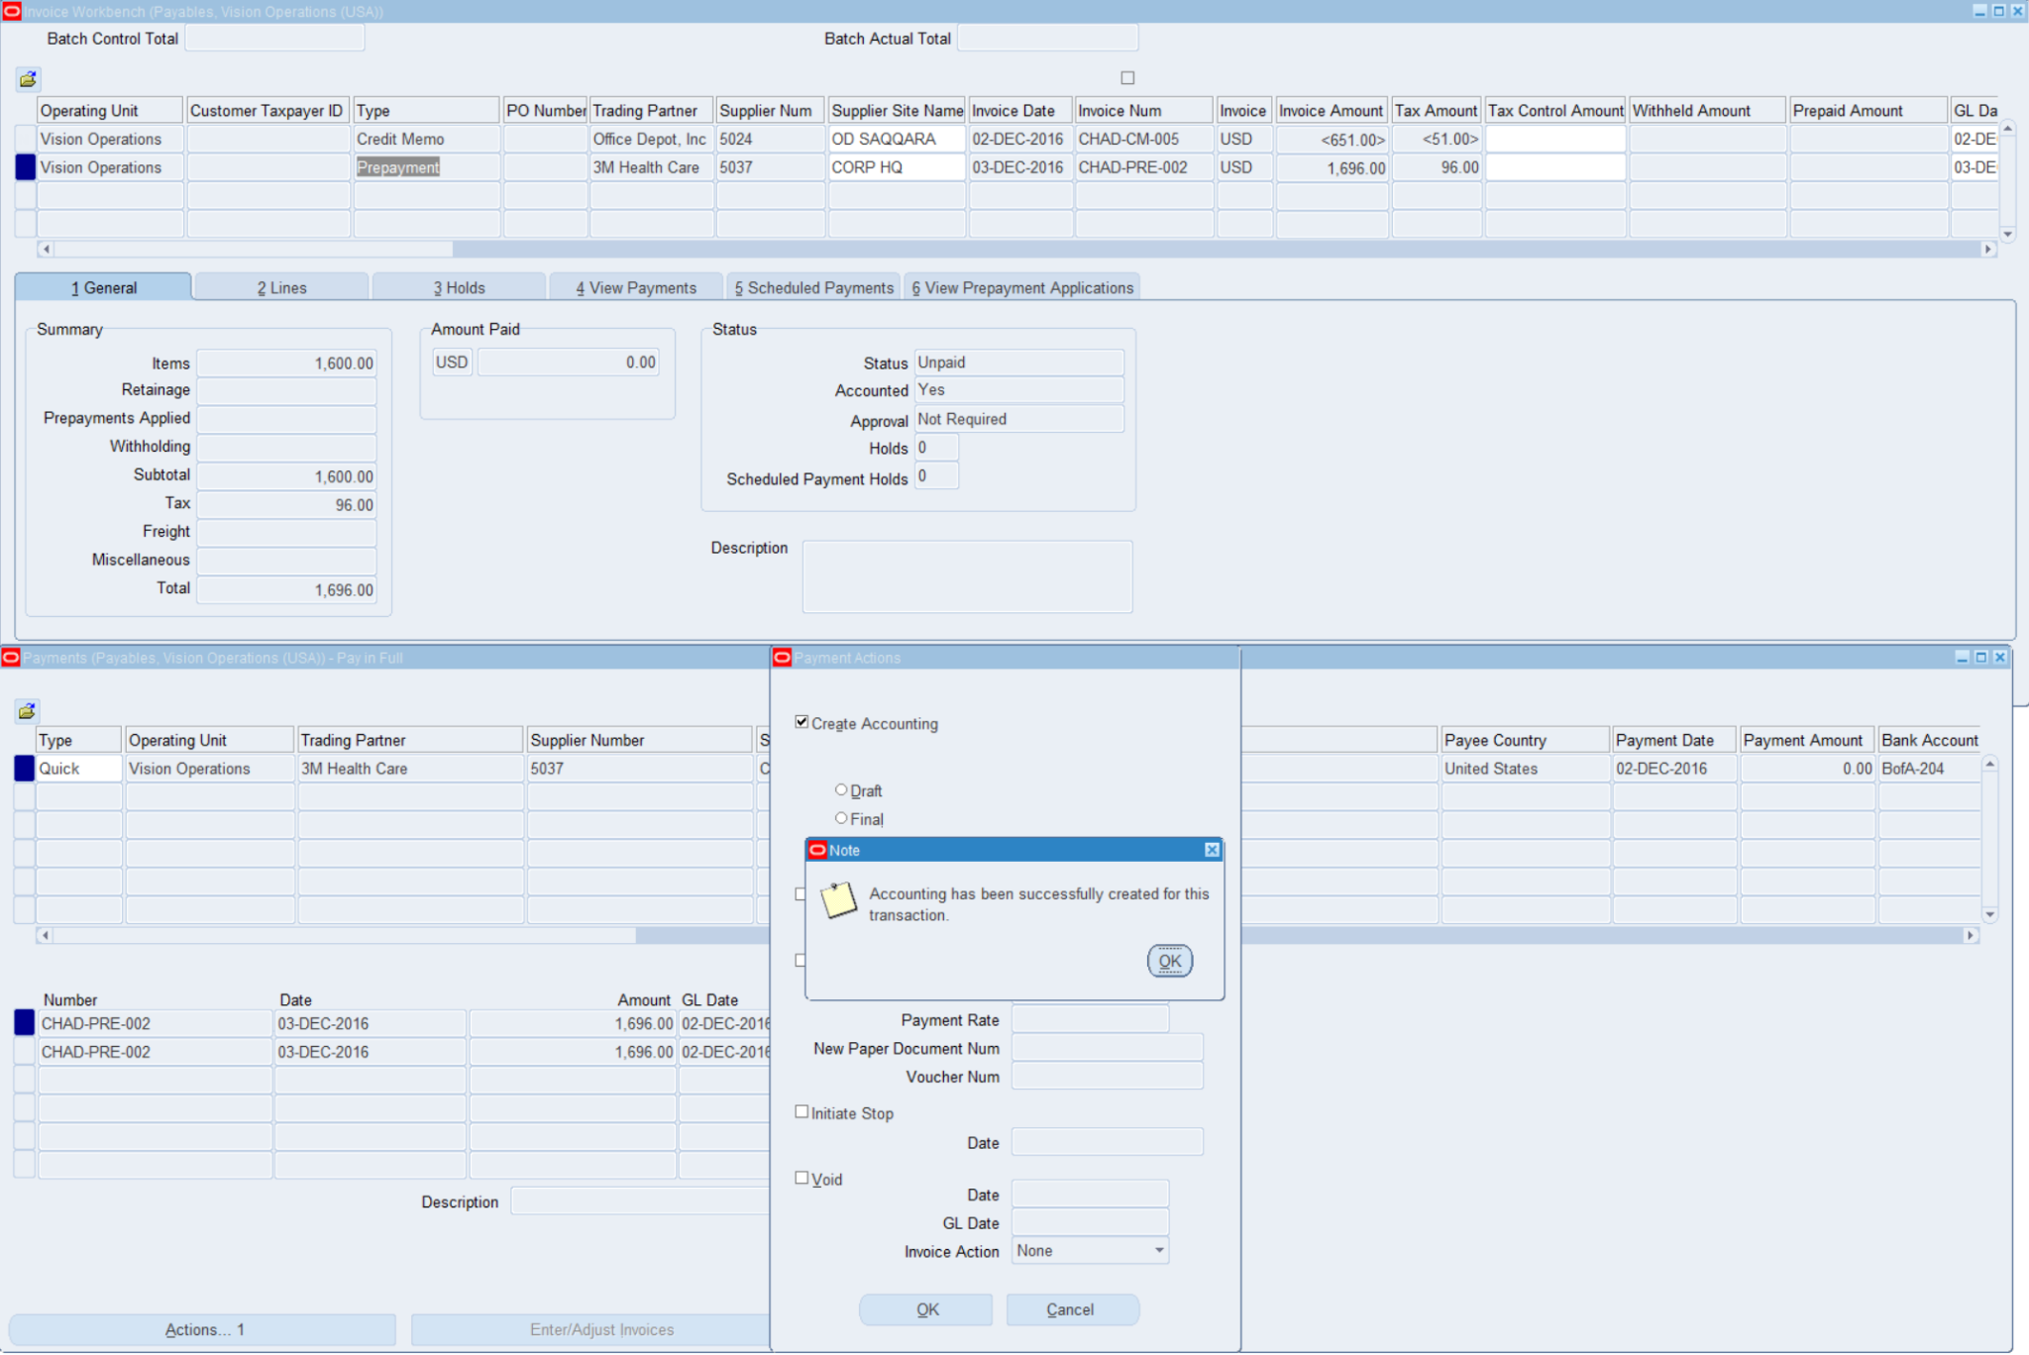

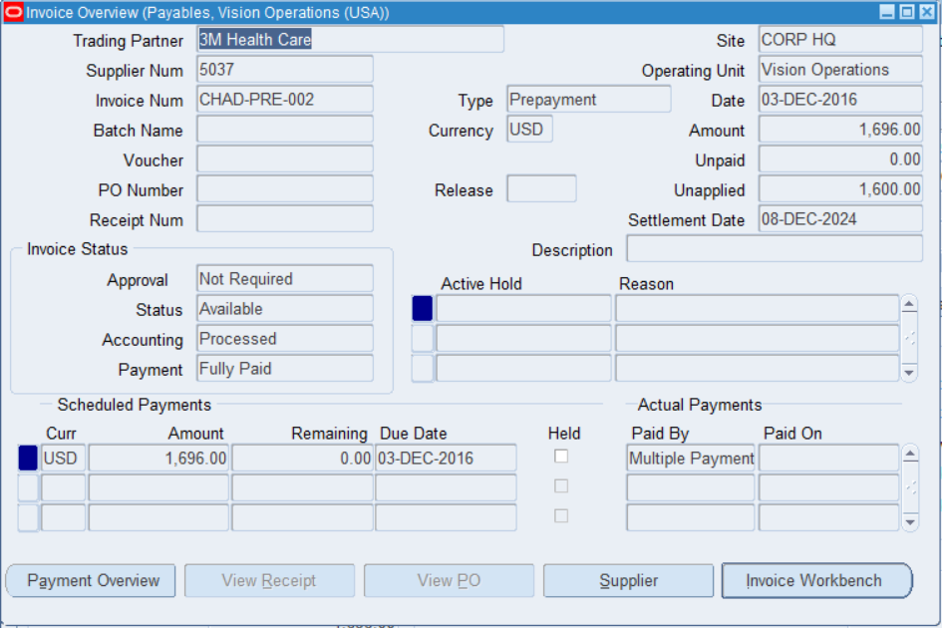

**Question #8**

**Make single Payment for Standard Invoice**

**#14: from here i started the invoice payment process by first clicking action and clicking the option of Pay in Full and clicked OK at the bottom**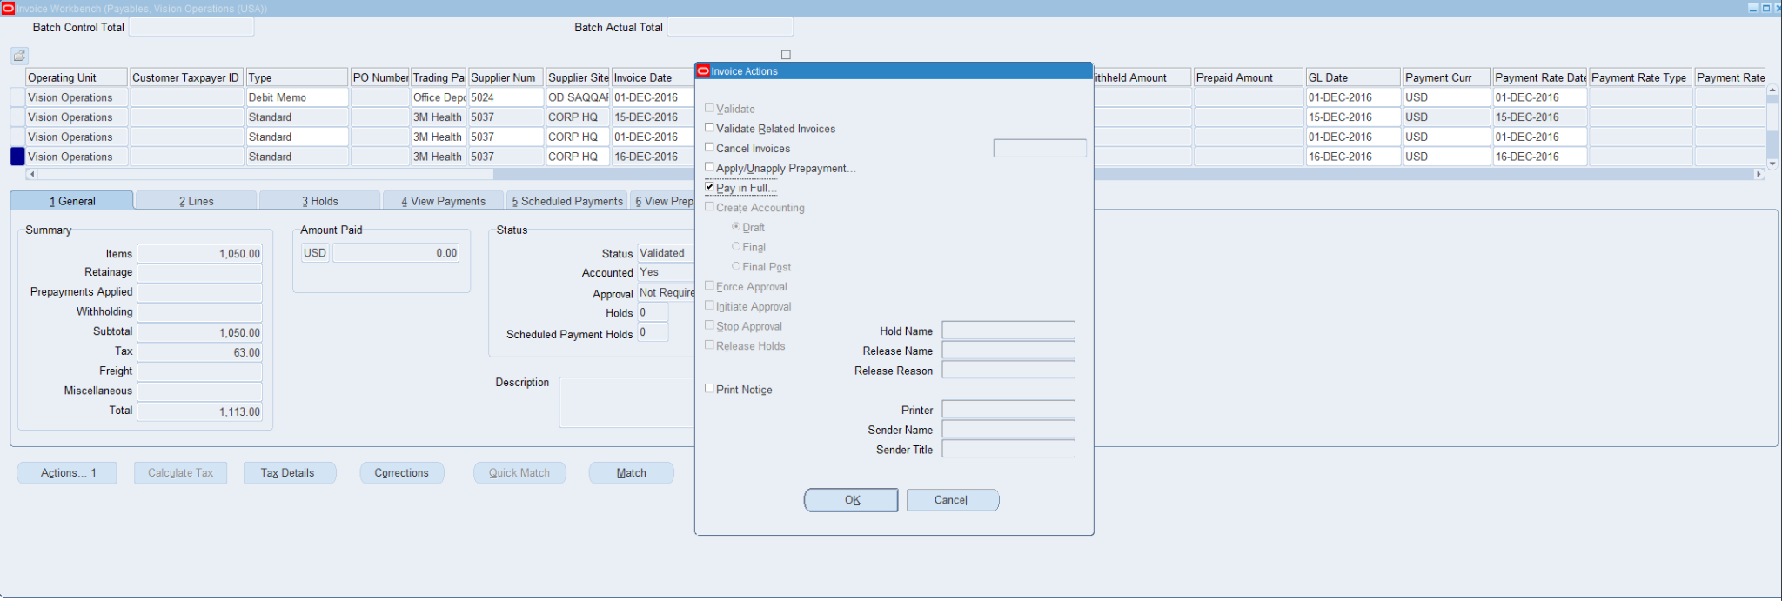

**#15:From here i add the required fields that are the payment date, the bank account, the payment method, to start the process of the payment invoice.**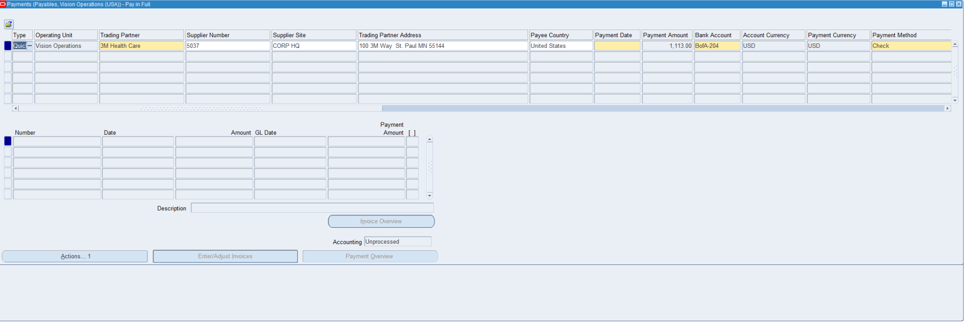

**#16:This is me adding the values of the payment date(12/05/24), the bank account(BofA-204), and the payment method(Check).**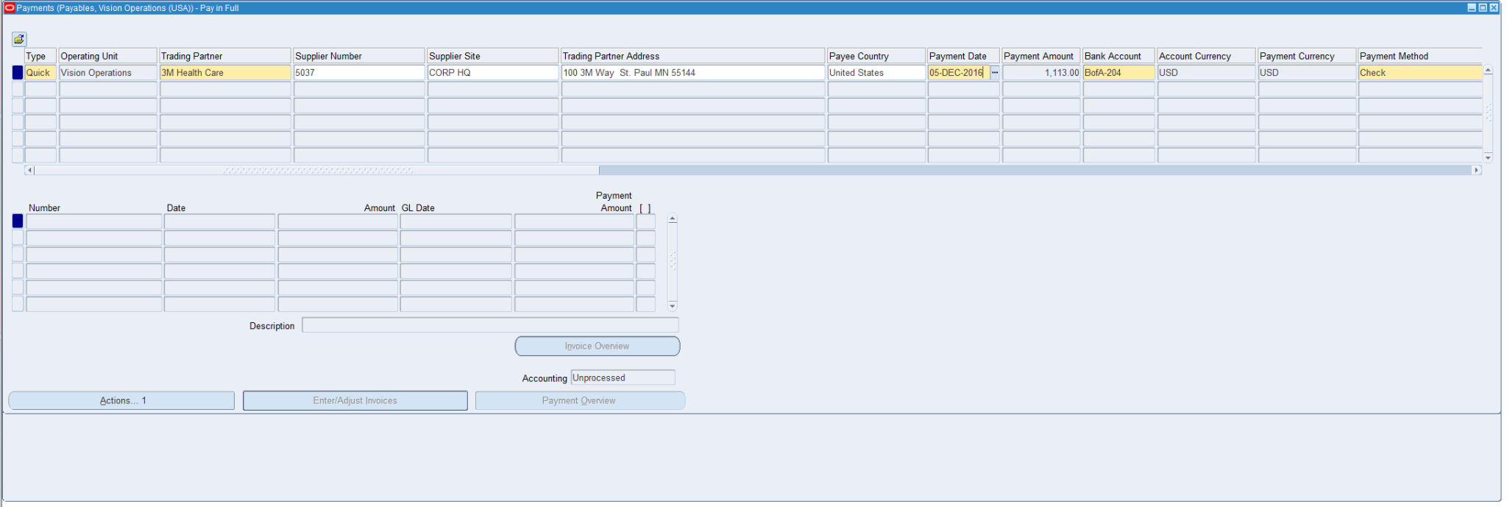

**#17:From here I am adding the payment Process Profile which is very important because it is needed for the type of Payment profile which consists of all different types of Currencies Such as USD,GBP, and others.** 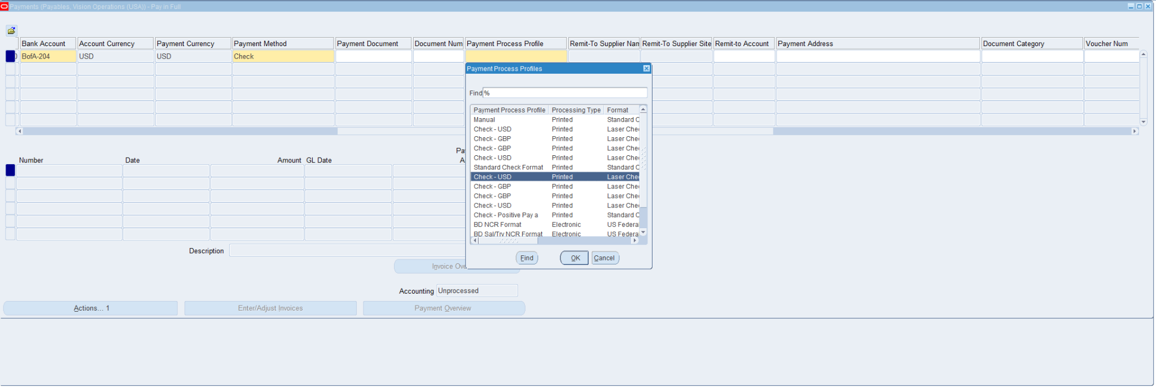

**#18: From here I have clicked on Check USD to complete the payment process profile which has created the payment document number and the document num for later use on checking the full document, i then click on actions to get the process to keep going.** 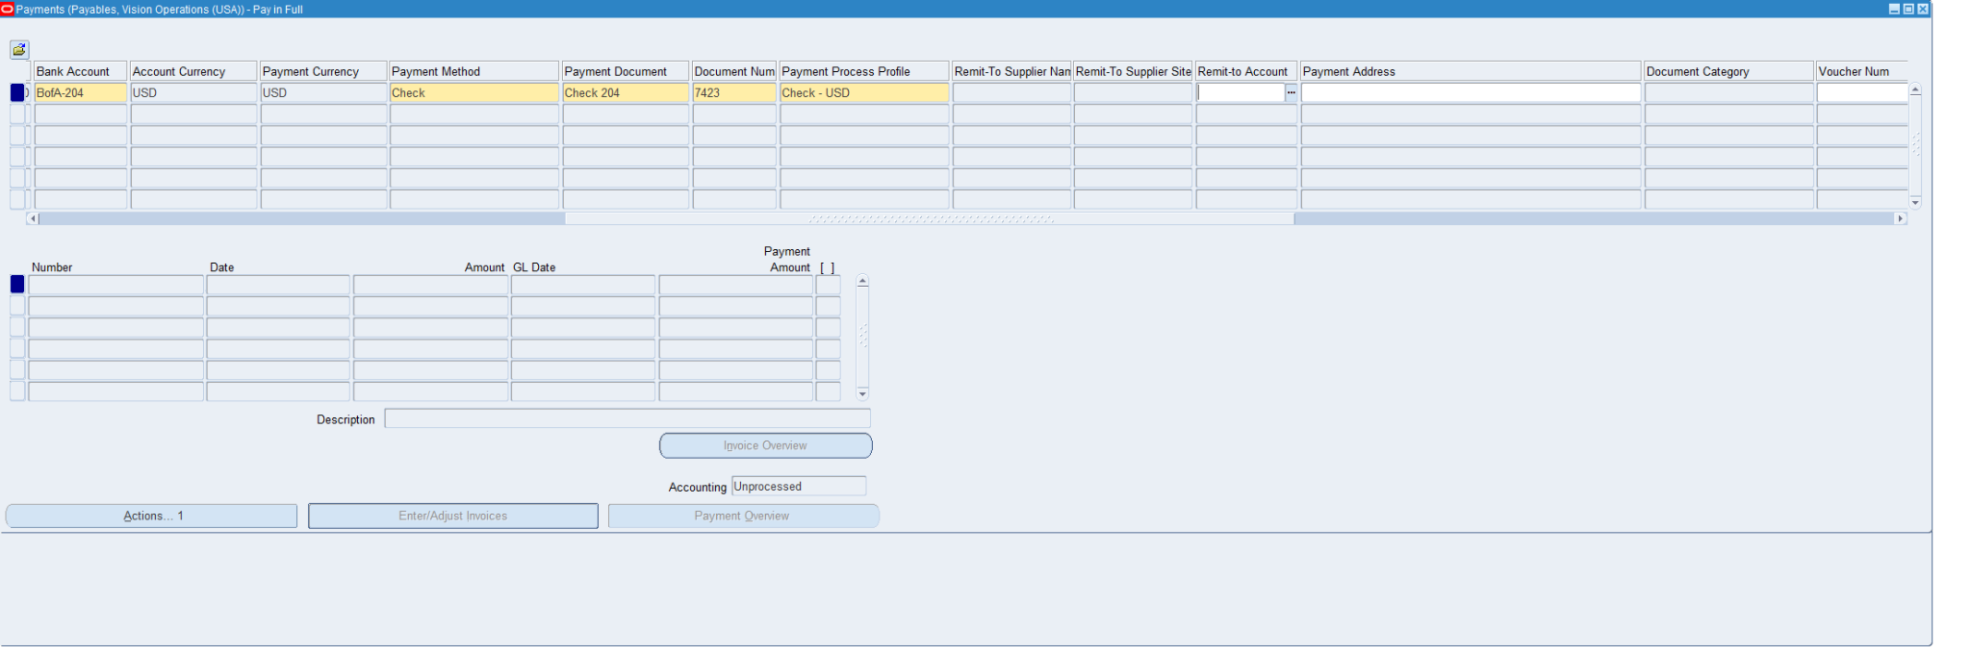

**Question #9**

**Review Payment Status**

**#19: from here i clicked on Create Accounting and Fina post to create the invoice payment form to check the results of the transaction**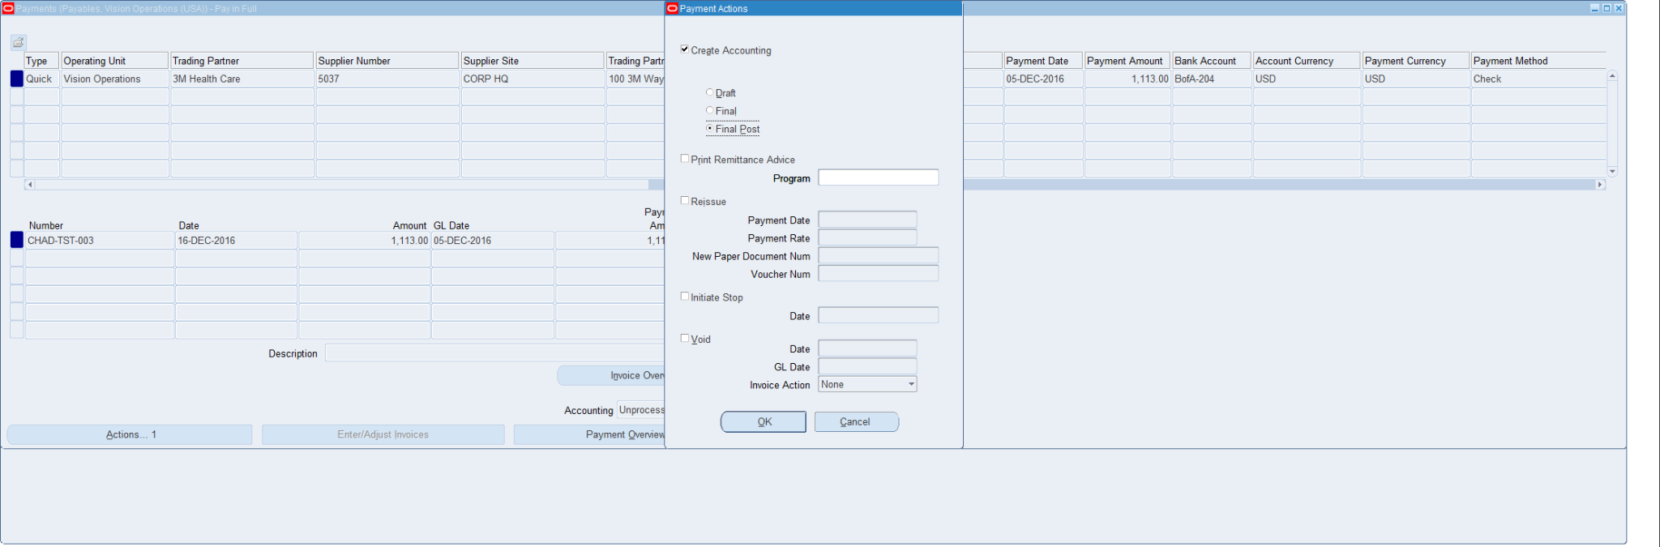

**#20:this is confirmation of the accounting account creating the transaction**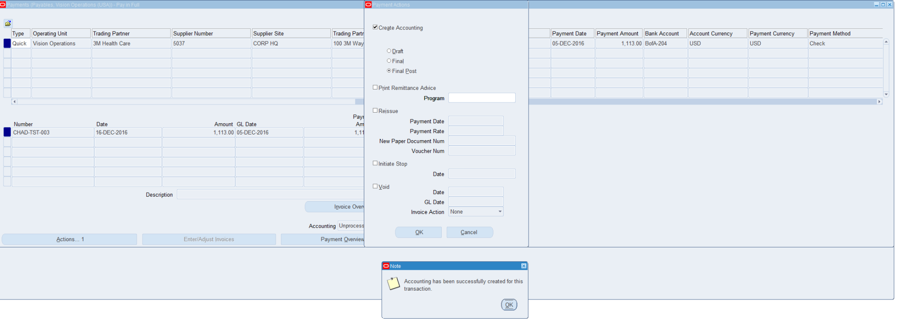

**Question #10**

**Review the Accounting Entries:**

**#21:This is the view of the payment overview which shows that the invoice number of CHAD-TST-003 is paid for 1,113.00**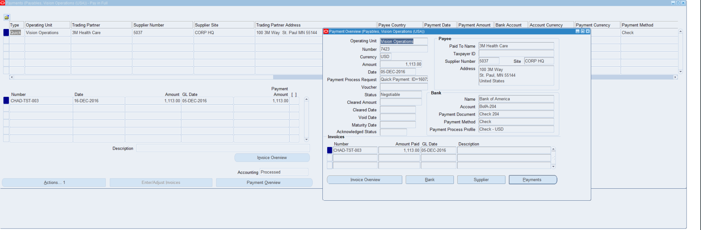

**#22: This is another screen showing the invoice payment information by clicking on payment from the payment overview.**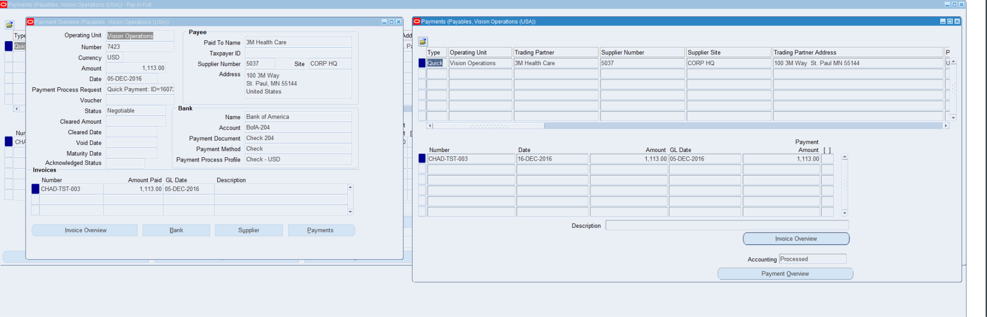

**#23: This is confirmation of the invoice amount being paid with the schedule payments and the actual payments highlighted in yellow**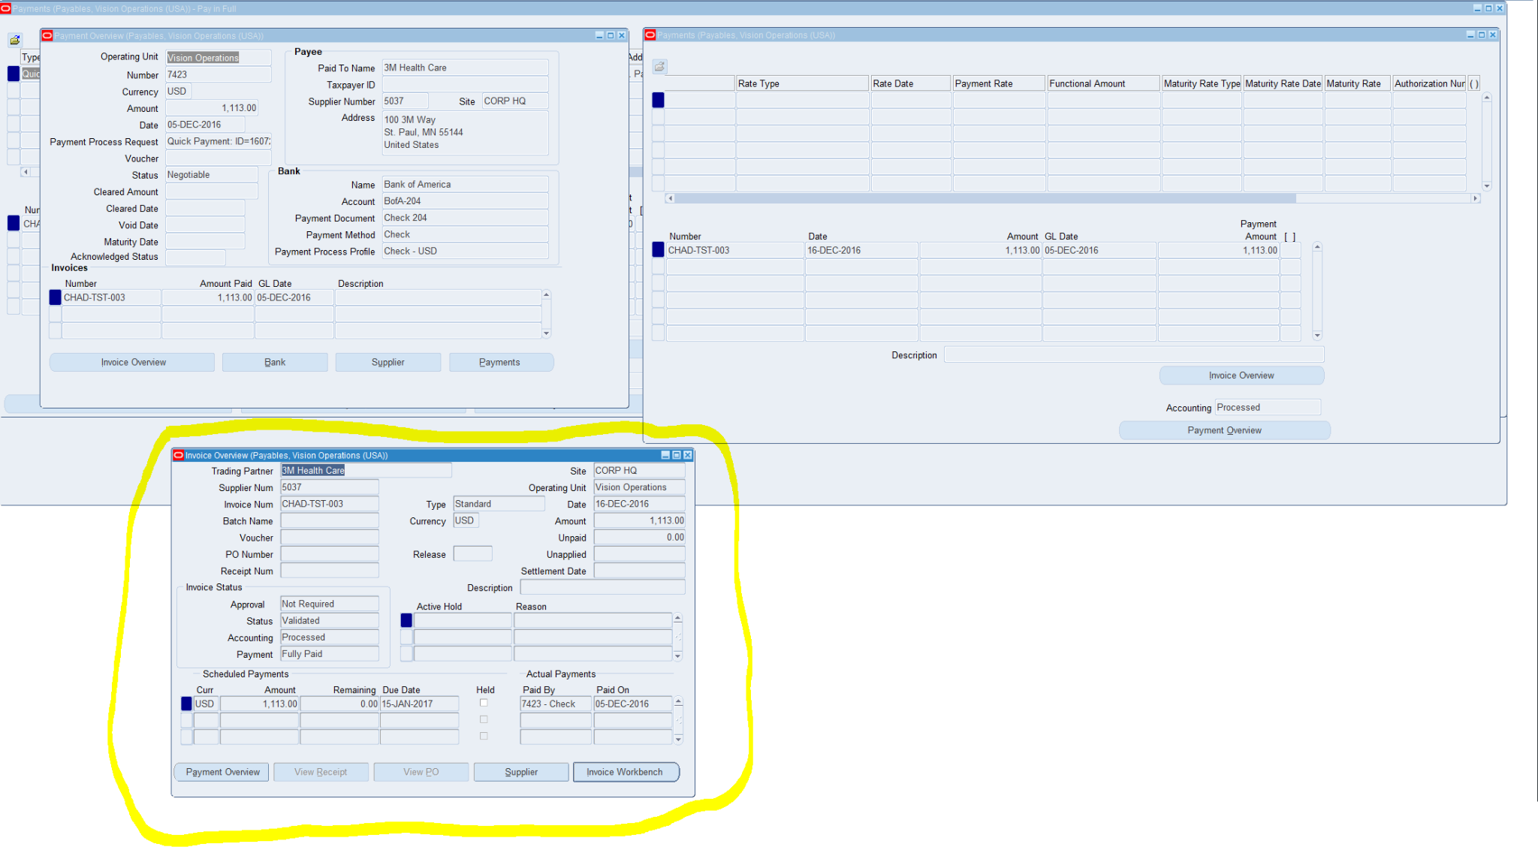

**#24: This is proof of the amount paid from my Invoice number CHAD-TST-003 of 1,113.00**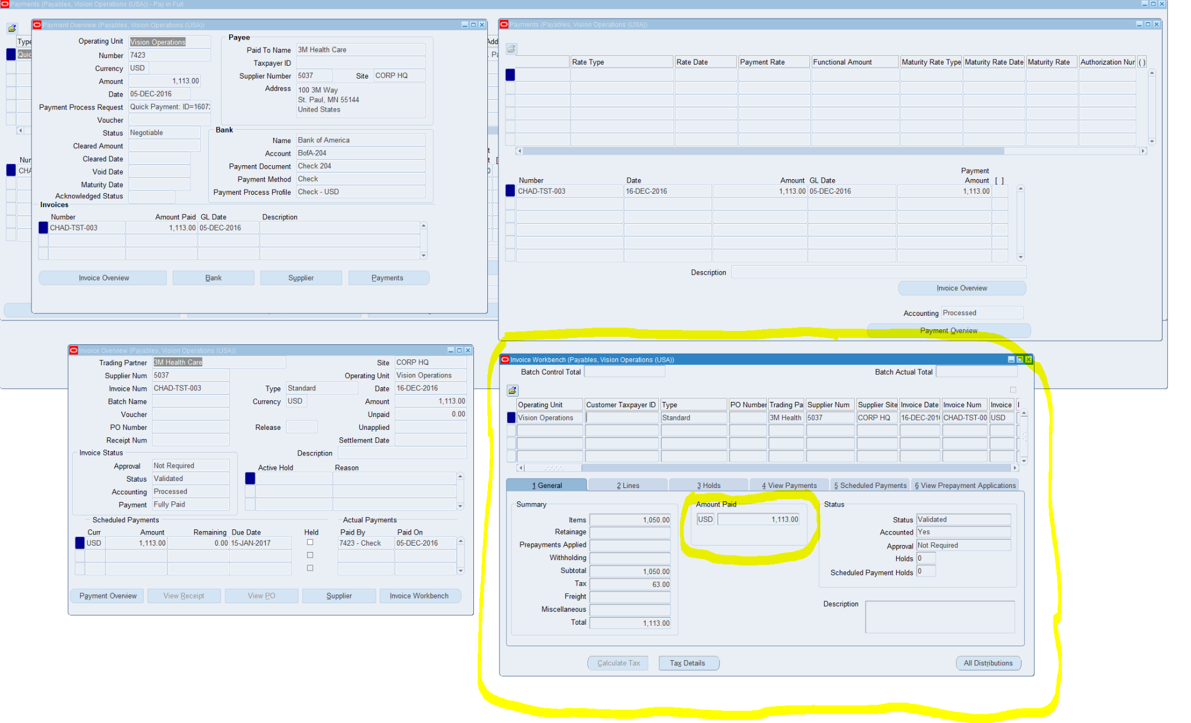

**Question #11**

**In Invoice Workbench how many types of Invoices are there?**

**There is 10 different types of invoices**

**Standard invoice**

**Credit Memo**

**Debit Memo**

**Prepayment Invoice**

**Expense Report**

**Mixed Invoice**

**Withholding Tax Invoice**

**Recurring Invoice**

**PO default Invoice**

**Interest Invoice**

**Question #12**

**Troubleshoot a Payables Issue: Hold**

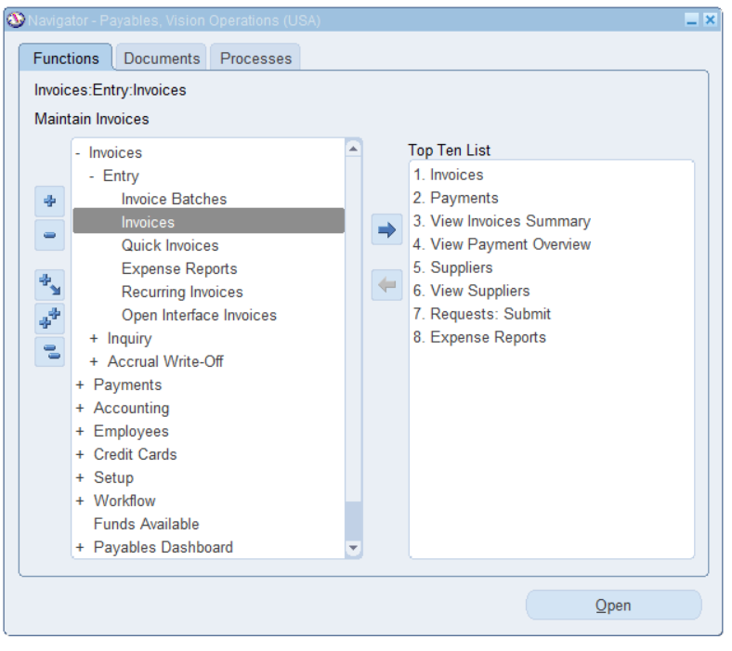

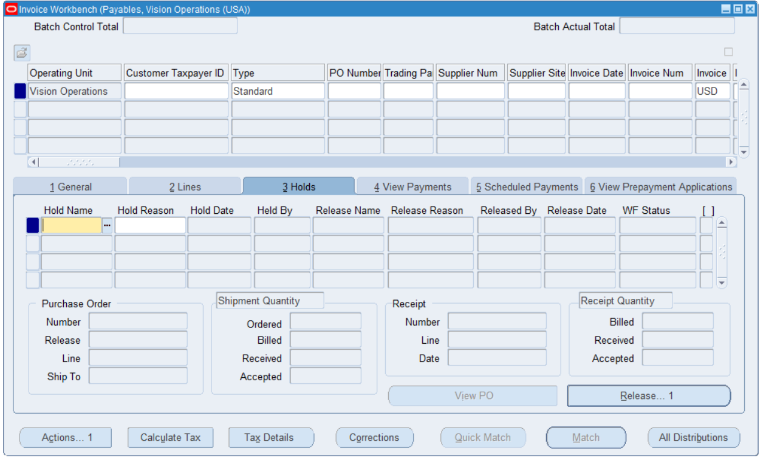

**You would solve this hold by updating the invoice and checking the hold details for different values, and making them the same.**

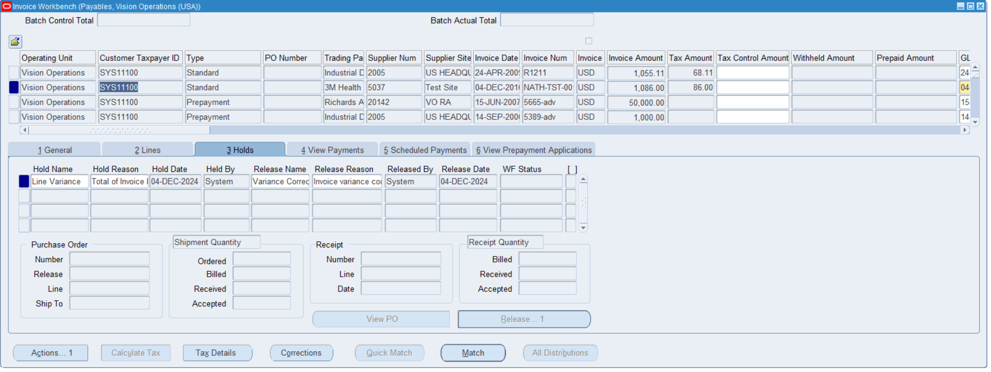

**Question #13**

**In the PAYMENT Workbench query the payment Document # (the Payment which you have done for Standard Invoice.**



**Question #14**

**Review the Payment accounting details.**



**Question #15**

**Review the Bank account Details (Disbursement Bank) which you use for Payment.**

